2025
MnDOT’s Safety Checklist For Large Energy Facility Projects
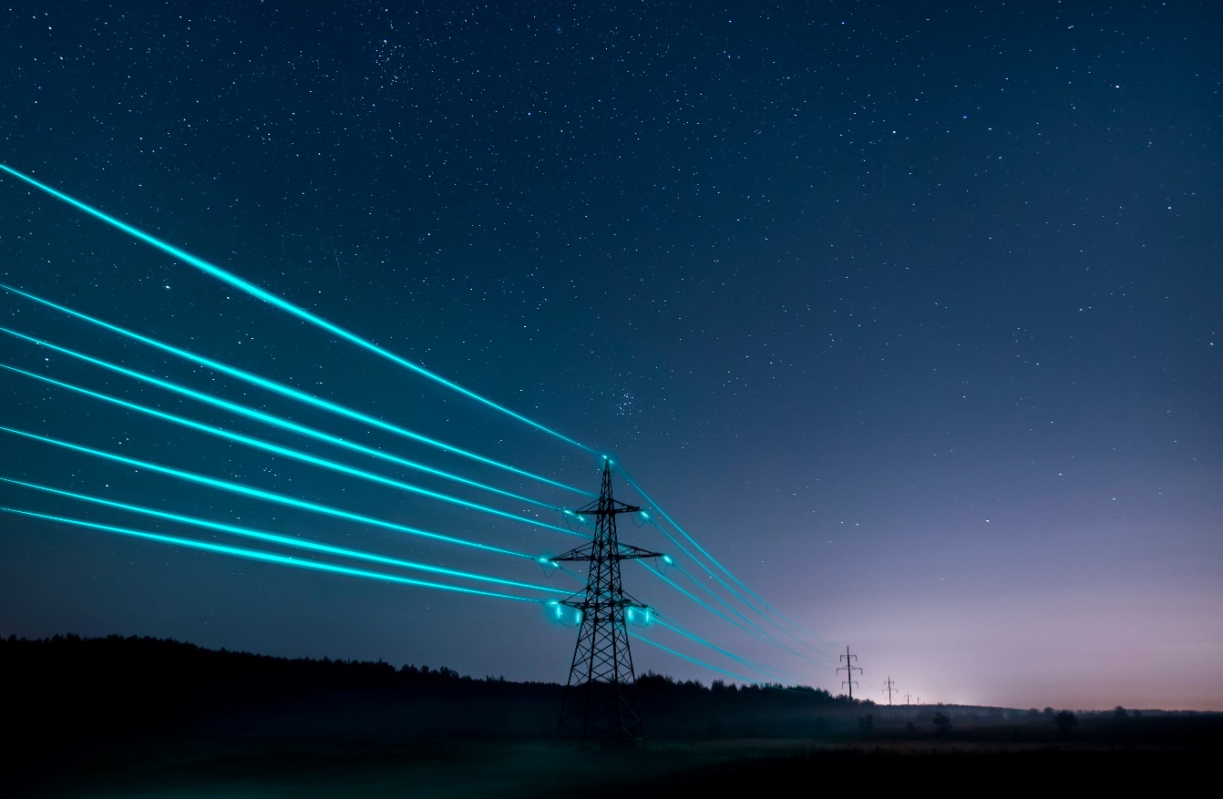
This document is intended as a checklist for the MnDOT OLM Utility Unit and District permit reviewers of large energy facility projects to identify safety concerns related to the construction of new large energy facility projects within MnDOT freeway right-of-way (R/W). This includes crossings, co-location within MnDOT rights of way, and projects with arial encroachment paralleling MnDOT right of way.
Changes to Utility Accommodation in the 2024 Legislative Session:

Sec. 17. Minnesota Statutes 2022, section 161.45

- High voltage transmission lines may be placed within MnDOT Right of Way which includes controlled access roadway/interstate right of way.
  - MnDOT (the Commissioner) has the authority to deny the installation based on safety and/or the operations of the transportation facility.
- Requires the Commissioner to provide written reason for denials to the Legislature and the Department Commerce & PUC
- The legislation describes the current MnDOT utility coordination process. This specifically calls out the coordination will occur with utility transmission line owners. The legislation indicates the requirement that utilities create a constructability report.

This checklist does not encompass all requirements for large energy projects but focuses on safety related topics. The checklist may not cover all safety concerns. If there are additional safety concerns that are not noted within this document, the permit reviewer should add additional rows as needed to identify the concerns and comment on them.
The material within this document is alphabetized by Safety Topic.

Safety Topic | References | Requirements | Meets Requirements (Yes/No/NA)
Aerial Lines | *8810.3500 - MN Rules Part | There shall be only a single pole line on the trunk highway right-of-way on either side of the center line thereof, unless otherwise authorized in the special provisions of the permit for construction.  Unless clearly indicated on the permit for construction sketch, the location of all brace poles, anchors, and anchor poles within the limits of the trunk highway right-of-way shall be approved by the district engineer or an authorized representative prior to actual installation.
Above Ground Structures | *UTILITY ACCOMMODATION MANUAL-1706321-v1.PDF | All above-ground structures shall be located outside the clear zone, except under the conditions listed below:  1. Right of way width limits are less than the clear zone requirements and it is not cost  effective to acquire additional right of way.  Attachment of additional utility equipment to breakaway light poles will not be permitted.  2. No ground structure or base protrudes more than four (4) inches above the surface  of the natural ground and can be maintained at that level.  3. The facility is shielded by an already existing guardrail or is located in an area that is inaccessible to vehicular traffic.
Access to Utility Facilities | *UTILITY ACCOMMODATION MANUAL-1706321-v1.PDF  *TRANSMISSION LINE GUIDELINES-1401674-v1 (2)-36801828-v1 (4).PDF | Subject to Section IV.D. (longitudinal installations) of the Utility Accommodation Manual, access to utility facilities may be permitted on both full or partial controlled access highways in limited conditions where alternate locations and means of access are not available or are impractical, as long as such access does not adversely affect safety or traffic operations or damage any facility. The following conditions also must be met:  a. Access for construction and/or servicing a utility facility shall be limited to frontage roads, nearby or adjacent public roads and streets, or trails along or near the highway right of way line, connecting only to an intersecting road.  b. In some circumstances, a locked gate along the fence may be used to meet periodic service access needs, subject to the following:  i. Access to and from the highway will be on the basis of a revocable permit.  ii. The gates shall be locked when not in use and can only be used by authorized utility personnel.  iii. Use shall not adversely affect traffic operations.  iv. Use will not give the utility owner a claim to permanent access rights  To the extent possible, access should be made from utility or private easements.
Aerial and Other Large Power Line Crossings (Guard Poles) | *https://edocs-public.dot.state.mn.us/edocs_public/DMResultSet/download?docId=1397146 | The applicant will not place guard poles or substitutions on the right of way before conductor stringing without prior review and approval of the proposed installation by the Assistant District Maintenance Engineer.
Aerial Encroachments/Blowout | *UTILITY ACCOMMODATION MANUAL-1706321-v1.PDF  *TRANSMISSION LINE GUIDELINES-1401674-v1 (2)-36801828-v1 (4).PDF | a. In addition to utility facilities that have fixed aerial encroachments within  MnDOT right of way, utility facilities that will have aerial encroachments that  are temporary in nature, such as the blowout zone (conductor movement  envelope) of wires being within MnDOT right of way, also require a MnDOT  permit.  b. Electric transmission facilities must be installed in locations so that induced  current does not impair the safety of the traveling public or workers within  MnDOT right of way or impair the public investment, short or long term, in the  transportation infrastructure. In assessing these conditions, MnDOT reviews  the highway facilities, including current and future roadway and right of way  use, features and appurtenances, and related highway activities. The  assessment includes evaluating zones where vehicles may travel and the  size of necessary equipment to repair, reconstruct, or construct such  facilities, at each unique segment of highway. From that zone of highway related  activities, the required clearance is added for the particular voltage of  the facility to create a buffer zone. Required clearances to create the buffer  zone are at a minimum taken from the Occupational Safety and Health  Administration or the National Electrical Safety Code as applicable. Locations  of poles shall be such that the blowout of wires does not infringe into the buffer zone.
Airport, height clearances, restrictions | *TRANSMISSION LINE GUIDELINES-1401674-v1 (2)-36801828-v1 (4).PDF | Contact aviationplanning.dot@state.mn.us. Contact Ryland Juran in MnDOT Aeronautics for additional information.  Part 77 surfaces are those imaginary surfaces used for the protection of airspace: https://www.ecfr.gov/current/title-14/chapter-I/subchapter-E/part-77
At Grade Intersections (ex. at top of ramp) | *TRANSMISSION LINE GUIDELINES-1401674-v1 (2)-36801828-v1 (4).PDF | Poles cannot be within sight corners of at-grade road crossings where sight distance could be impaired.
Bridge Constraints | *UTILITY ACCOMMODATION MANUAL-1706321-v1.PDF | Electric power line installations greater than 35 kV on highway bridge structures shall  generally, not be permitted except in extraordinary circumstances, and then only after  a detailed analysis of all other construction methods or alternatives are determined  impracticable. The increased cost of alternative construction methods will not be  considered a reason for the installation of high-voltage transmission lines on bridge  structures. The utility owner must also address the following safety and operational  issues to MnDOT’s satisfaction.  a. The proposed installation will not pose a hazard to bridge and roadway  construction and maintenance personnel working on or near the installation.  b. The proposed installation will not pose a hazard to the motoring public.  c. The proposed installation will include adequate shielding protection to  eliminate adverse effects of Electric Magnetic Field (EMF) on radio  interference, fuel ignition potential, potential increased corrosion deterioration  of reinforcing and structural steel, and long-term health effects of  maintenance personnel working on the bridge for extended periods of time.  d. The proposed installation will be adequately designed to prevent the  possibility of any shock hazards when installed on bridges that allow  overtopping of flood waters or submersion of superstructure in high water.  e. The proposed installation would not pose environmental problems now or in  the foreseeable future.  f. The proposed installation shall be designed to allow shut down of lines, upon  request of MnDOT, and to allow area that is serviced by the transmission line  to have adequate and available alternate sources of power.  The horizontal and vertical location of overhead power and communication lines  relative to a highway bridge or other structure shall provide adequate clearance for construction and maintenance activities.
Clear Zone | *Code of Federal Regulations:23 CFR § 645.209(c)  *TRANSMISSION LINE GUIDELINES-1401674-v1 (2)-36801828-v1 (4).PDF  *UTILITY ACCOMMODATION MANUAL-1706321-v1 (1).PDF  *MnDOT Facility Design Guide: Facility Design Guide-18684932-v20 (1).pdf | On Federal-aid or direct Federal highway projects, new above ground utility installations, where permitted, shall be located as far from the traveled way as possible, preferably along the right-of-way line. No new above ground utility installations are to be allowed within the established clear zone of the highway unless a determination has been made by the transportation department that placement underground is not technically feasible or is unreasonably costly and there are no feasible alternate locations. In exceptional situations when it is essential to locate such above ground utility facilities within the established clear zone of the highway, appropriate countermeasures to reduce hazards shall be used. Countermeasures include placing utility facilities at locations which protect or minimize exposure to out-of-control vehicles, using breakaway features, using impact attenuation devices, using delineation, or shielding.  In rural areas, new overhead facilities shall be located on a uniform alignment as far from the roadway as possible, preferably near the right of way line. Guy wires placed within the right of way shall be held to a minimum. They may be located as needed but shall not be located within the clear zone.  Where there is no feasible alternative to place the new facilities outside the clear zone, then any new facility that projects more than 4" above the ground line will require the use of protective barriers, i.e. use breakaway features, impact attenuator devices, use delineation, shielding, or place utility facilities at locations which protect or minimize exposure to out-of-control vehicles.  Refer to Appendix A and the MnDOT Facility Design Guide for Design Guidance on Clear Zone widths.
Conformity | *8810.3400 - MN Rules Part | Installations shall be made in conformity with all applicable laws, rules, and codes covering said installations. All installations shall be made in conformity with rules of governmental agencies for the protection of the public.
Operations and Maintenance |  | Consult with District Maintenance Engineers for impacts including existing assets that may have to be relocated due to the proposed transmission project.
Crossing Distance at Interchanges and Separated Grade Crossings | *TRANSMISSION LINE GUIDELINES-1401674-v1 (2)-36801828-v1 (7).PDF  *LRFD Bridge Design Manual - MnDOT | At ramped interchanges, lateral utility crossings are allowed at a minimum distance of 50' outside the interchange ramps. At interchanges with bridges over the highway, the distance is determined on a bridge-by-bridge basis. When bridges run parallel with the road, a minimum distance of 50' from the utility structure is required.  Refer to LRFD Bridge Design Manual for specific details relating to utility requirements.
Crossings | *TRANSMISSION LINE GUIDELINES-1401674-v1 (2)-36801828-v1 (4).PDF  *UTILITY ACCOMMODATION MANUAL-1706321-v1 (1).PDF | Utility crossings of highways shall be perpendicular to the highway alignment, where practicable, with minimum height requirements of 32'.  New utility facility installations and relocations of existing utility facilities may be permitted to cross a freeway. Where a utility facility that is carried over or under a freeway, provisions should be made for the utility facility to cross the freeway in such a manner that it can be constructed and serviced without access from the freeway traffic lanes or ramps.  Multiple crossings of a freeway by the same utility facility should be limited to the extent possible, particularly within short distances.  For utility crossings on highways with full or partial access control, all supporting structures and above ground appurtenances shall be located outside the access control line, and preferably outside the right of way line. Installation and maintenance shall be from frontage roads, crossroads, or streets, whenever practicable, or otherwise from outside the access control line and preferably outside the right of way line. Where required for support, exceptions may be allowed for intermediate supporting poles to be placed in medians of sufficient width that will provide the clear zone from the edges of both travelled ways. At interchange areas, supports for overhead utility facilities shall be permitted only when they are located beyond the clear zone of the freeway traffic lanes or ramps, sight distance is not impaired, and access can be safely obtained. More information about freeway crossings may be found in Section III of the Utility Accommodation Manual.
Design Requirements | *UTILITY ACCOMMODATION MANUAL-1706321-v1.PDF | a. All overhead lines regardless of voltage or metallic content shall meet the  requirements of the National Electrical Safety Code. Where the code  apparently does not apply, the minimum standards in that code for the lowest  voltage line shall apply. Utility owners or industry standards may prescribe  more protection.  b. Designs employing self-supporting, armless, single-pole construction, with  vertical alignment of wires, cables, or other techniques permitted by  governmental or industry codes should be considered whenever feasible and  particularly if the alternative is locating the utility facility at other than the right  of way line. However, they must be conducive to safe traffic operations.  c. Where there are existing poles for overhead utility facilities, new overhead  utility facilities will be required to co-locate on those poles unless the new  facilities cannot be reasonably accommodated. Written documentation of  those reasons must be supplied to MnDOT upon request.  d. The distance between utility poles should be the longest feasible span lengths consistent with geometric and design line loading considerations.  All utility installations on, over, or under highway right of way and attachments to  highway structures shall be of durable materials designed for a long service life  expectancy and relatively free from routine servicing and maintenance.  Utility and highway facilities should be separated to avoid damage during installation  and to provide for reasonable success in locating facilities with electromagnetic utility  locating devices. Separation of the facilities from highway facilities or other utility  facilities may require the acquisition of additional property by the utility owner. Utility  facilities should also be separated from one another as required by appropriate  codes and ordinances.
Distance between utility poles | * UTILITY ACCOMMODATION MANUAL-1706321-v1 (1).PDF | Distance should be the longest feasible span consistent with geometric and design line loading considerations.
Does not impair highway or protected visual quality | * UTILITY ACCOMMODATION MANUAL-1706321-v1 (1).PDF
Does not interfere with the free and safe flow of traffic | * UTILITY ACCOMMODATION MANUAL-1706321-v1 (1).PDF
Does not unreasonably increase the difficulty or future cost of highway const. or maintenance | * UTILITY ACCOMMODATION MANUAL-1706321-v1 (1).PDF | Refer to MnDOT’s Capitol Highway Investment Plan (CHIP) and MnDOT’s State Highway Investment Plan (MnSHIP) to determine future projects in the corridor:  CHIP: https://www.dot.state.mn.us/planning/10yearplan/index.html  MnSHIP: https://www.minnesotago.org/mnship-plan  Design clear zone width based on proposed project design elements.
Existing Soil Type/Dewatering |  | Contact Rich Lamb for consultation.
Existing subsurface utilities/ Impacts on Other Existing Utility Facilities/Existing Structures | *8810.3400 - MN Rules Part | The utility facility and installation shall not interfere with any existing utility facilities on the trunk highway right-of-way.
Freeway Longitudinal Installations | *UTILITY ACCOMMODATION MANUAL-1706321-v1.PDF | Except for crossings permitted under Section III.B of the Utility Accommodation Manual, installation of new utility facilities shall not be allowed within the right of way of any freeway, except in special cases under strictly controlled conditions. If an exception is granted, so that such an installation is allowed or allowed to remain, individual service connections shall not be permitted, the utility facility shall not be installed, maintained, operated, or serviced by direct access from the fully controlled access roadways or connecting ramps, and the utility facility shall not interfere or impair the safety, design, construction, operation, maintenance, stability, or future expansion of the highway.  Installations that will have aerial encroachments that are temporary in nature, such as the blowout zone (conductor movement envelope) of wires being within MnDOT right of way, but do not permanently encroach on the MnDOT right of way may be allowed and require a MnDOT permit. Accommodations of temporary aerial encroachments of this type do not require an exception from the FHWA.  Longitudinal installations on highways with full control of access shall not be permitted. In extreme cases, exceptions may be allowed as discussed in Section III (Freeways) of the Utility Accommodation Manual.
Grounding | *https://edocs-public.dot.state.mn.us/edocs_public/DMResultSet/download?docId=1397146 | The applicant shall design, construct, and operate the power line in a manner that the maximum induced steady-state short-circuit current shall be limited to five milliamperes, root mean square (rms) alternating current between the ground and any non-stationary object within the highway right of way, including but not limited to large motor vehicles and maintenance or construction supplies, equipment or vehicles. The applicant shall ensure that all fixed metallic objects on or adjacent to the highway right of way, including but not limited to signs, light standards and fences that parallel or cross the right of way, are properly grounded to the extent necessary to limit the induced short-circuit current between ground and the object so as not to exceed one milliampere rms under steady-state conditions of the power line and to comply with the ground fault conditions specified in the National Electric Safety Code. The applicant shall be responsible for the maintenance of these obligations for as long as the aerial power line remains in operation and shall, on a regular basis, inspect all fixed metallic objects for proper grounding.
Location | *UTILITY ACCOMMODATION MANUAL-1706321-v1.PDF  *TRANSMISSION LINE GUIDELINES-1401674-v1 (2)-36801828-v1 (4).PDF | Guy wires placed within the right of way shall be held to a minimum. They  may be located as needed but shall not be located within the clear zone.  New above ground facilities shall be located outside the clear zone. If the  clear zone extends to the right of way line, then no installation should be  permitted unless there is no feasible alternative. Where there are no feasible  alternatives, new facilities that project more than four (4) inches above the  ground line should be shielded by existing traffic barriers or placed in areas  that are inaccessible to vehicular traffic.  Longitudinal installation of overhead utility facilities on highway right of way  shall be limited to single pole construction. Transverse installation of  overhead utility facilities shall also be limited to single pole construction  where practicable, but may also be approved to use the same type of  supports that are used on the portion of the pole immediately adjacent to the  highway right of way provided all other requirements in this section are met.  Where irregular shaped portions of the right of way extend beyond or do not  reach the normal right of way limits, variances in the location of utility facilities  should be allowed to maintain a reasonably uniform alignment for longitudinal  installations. Such installations will reduce the need for guys and anchors  between poles and roadway.  The horizontal and vertical location of overhead power and communication  utility facilities relative to a highway bridge or other structure shall provide  adequate clearance for construction and maintenance activities.  Locating poles in potential target locations, such as beyond lane drops,  sections where the pavement narrows, and tee intersections, should be  avoided.  Installation of utility facilities will not be allowed:  - On any MnDOT owned lighting or signal system pole or structure.  - On any break-away light pole  - In any area where the installation or operation of the facility will interfere with any existing or planned state or federal communication systems.  Placement for aerial lines are typically within the outer 5’ of R/W.
Median Installations | *UTILITY ACCOMMODATION MANUAL-1706321-v1.PDF | Utility facilities shall not be located in a highway median except for those serving the highway. This does not prohibit crossings as allowed under Section IV. C of the Utility Accommodation Manual.
Military installations |  | Projects near military installations require consultation and coordination.
Overhead Lines | * UTILITY ACCOMMODATION MANUAL-1706321-v1 (1).PDF | Overhead lines must meet the requirements of the National Electrical Safety Code. Where the code apparently does not apply, the minimum standards in that code for the lowest voltage line shall apply. Utility owners or industry standards may prescribe more protection.
Pole Construction | * UTILITY ACCOMMODATION MANUAL-1706321-v1 (1).PDF  *TRANSMISSION LINE GUIDELINES-1401674-v1 (2)-36801828-v1 (4).PDF | Longitudinal installation of overhead utility facilities on highway R/W shall be limited to single pole construction. Transverse installation is also single pole construction but may be approved to use the same type of supports as the pole immediately adjacent to the highway R/W provided all requirements in the MnDOT Utility Accommodation Manual-Section 8 are met.  There shall only be a single pole line on the trunk highway right-of-way on either side of centerline. Collocation, burying and other efforts must be exhausted in cases of a second line proposal within highway right-of-way.
Restoration to original condition | *8810.3400 - MN Rules Part | Upon completion of an installation, the utility shall restore the trunk highway right-of-way to its original condition. The utility shall then notify the office of the assistant district engineer, maintenance, or project engineer of the completion of the work so that inspection can be made to determine its acceptability.
ITS Infrastructure, buried state fiber, sensors and cameras |  | Proposed projects should consult with RTMC to determine impacts, relocations and what MnDOT devices need additional grounding due to induced voltage issues. Ensure district traffic are coordinating with RTMC on what devices would be impacted and requiring relocation/additional grounding.
Topsoil and sod | *8810.3400 - MN Rules Part | Wherever topsoil and sod are disturbed they shall be replaced and maintained satisfactorily until the turf is established.
Traffic Control | *eCFR :: 23 CFR 645.209 -- General requirements.  *https://edocs-public.dot.state.mn.us/edocs_public/DMResultSet/download?docId=1706321  *8810.3400 - MN Rules Part  *23 CFR § 645.209(c)  *TRANSMISSION LINE GUIDELINES-1401674-v1 (2)-36801828-v1 (4).PDF | When a utility installation, adjustment, or maintenance activity will affect movement of traffic or traffic safety, a traffic control plan is required.  The traffic control plan and the application of traffic control devices shall conform to the standards set forth in the current edition of the “Manual on Uniform Traffic Control Devices” (MUTCD) and 23 CFR part 630, subpart J. Also include provisions for rerouting or detouring traffic, traffic control measures to be employed, procedures for utility traffic control plans, limitations on vehicle parking and materials storage, protection of open excavations, etc.  Traffic control for utility construction shall conform to the Minnesota Manual on  Uniform Traffic Control Devices (MN MUTCD) and the Temporary Traffic Control  Zone Layouts Field Manual (Part 6K of the MN MUTCD). Any utility construction  operation shall be planned with full regard to safety, and interference with roadway  traffic shall be kept to an absolute minimum.  - No utility work shall begin until all appropriate traffic control devices are in place and  fully functional. The utility owner must maintain these traffic control devices until  completion of all utility work.  - For those operations that entirely close or encroach upon a traffic lane, shoulder, or  ramp, the utility owner must submit or reference a proper traffic control plan as part  of its permit application. On heavily travelled highways, utility construction  operations that interfere with traffic will not be allowed during periods of peak traffic  flow.  - All utility work should use the appropriate typical diagrams in the Temporary Traffic  Control Zone Layouts Field Manual. If desired, a utility owner may develop its own  traffic control plan contingent upon MnDOT approval. MnDOT may require a more  extensive traffic control plan if:  - Utility work is to be performed during nighttime hours  - Traffic control zones are to be left overnight or during other non-work times  - Utility work is to be performed in a continuously moving traffic control zone  - Typical diagrams in the Temporary Traffic Control Zone Layouts Field Manual do not adequately cover utility work.  The applicant shall accomplish all work in a manner that will not be detrimental to the highway and that will safeguard the public. The utility owner will develop a written traffic control plan based upon the Minnesota Manual on Uniform Traffic Control Devices (MN MUTCD) and the Temporary Traffic Control Zone Layout Field Manual (Part 6K of the MN MUTCD). The MnDOT Traffic Office must approve the plan.  When necessary, barricades, warning devices, and flaggers shall be provided by the utility during all phases of their construction and maintenance operations on the trunk highway right-of-way.  Early coordination is required to determine traffic impacts and required traffic permits. No interference with traffic is allowed without approval from the District Permit Office. MnDOT’s District Permit Office shall be notified at least 2 days before a lane closure or any interference with traffic flow. Law enforcement officials with appropriately equipped vehicles will provide traffic control for aerial crossings of trunk highways. Traffic may only stop for 5 minutes or as directed by the officer. Use the MN-Temporary Traffic Control Zone Layouts Field Manual for proposed layouts: Complete-Manual-37176174-v1.PDF
Trees, brush, and vegetation | *https://edocs-public.dot.state.mn.us/edocs_public/DMResultSet/download?docId=1706321  *8810.3400 - MN Rules Part  *TRANSMISSION LINE GUIDELINES-1401674-v1 (2)-36801828-v1 (4).PDF | At the time of construction of the utility and at the times of subsequent maintenance, prior approval shall be obtained from the district engineer or an authorized representative for the cutting and trimming of trees within the trunk highway right-of-way. Wherever trees are cut the resulting stumps shall be removed unless otherwise provided in the special provisions of the permit for construction. Any holes caused by stump removal shall be backfilled, the area leveled, and all materials associated therewith disposed of outside the trunk highway right-of-way. The utility shall advise the district engineer or an authorized representative at least 48 hours in advance of its intent to start clearing and grubbing operations so that proper supervision can be provided.  Burning or disking operations and/or the use of chemicals to control or kill trees, brush, and other vegetation is prohibited without prior approval from the assistant district engineer, maintenance.  Wherever trees are cut the resulting stumps shall be removed unless otherwise provided in the special provisions of the permit for construction. Any holes caused by stump removal shall be backfilled, the area leveled, and all materials associated therewith disposed of outside the trunk highway right-of-way. Burning or disking operations and/or the use of chemicals to control or kill trees, brush, and other vegetation is prohibited without prior approval from the assistant district engineer, maintenance.  Vegetation inside the R/W must be allowed to attain a minimum height of 35 feet.
Vertical Clearance | * UTILITY ACCOMMODATION MANUAL-1706321-v1 (1).PDF  *https://edocs-public.dot.state.mn.us/edocs_public/DMResultSet/download?docId=1397146  *TRANSMISSION LINE GUIDELINES-1401674-v1 (2)-36801828-v1 (4).PDF | The minimum aerial clearance on non-oversize/overweight corridors must be 22 feet for all road crossings. If the applicant cannot meet this minimum clearance, it must bury the crossing at a minimum depth of 5 feet below the road surface. All aerial crossings on oversize/overweight corridors must be a minimum height of 24 feet. If the applicant cannot meet this minimum clearance, it will bury the crossing at a minimum depth of 5 feet below the road surface. See the web site at: https://www.dot.state.mn.us/ofrw/freight/data.html for further information. All down guys and anchors, including breakaway types, must be placed out of the MnDOT clear zone.  For all structures within MnDOT right-of-way, a minimum vertical access zone of 10 feet plus the OSHA Safety Zone (Table A), is required to allow for maintenance and future construction activities requiring boomed equipment.  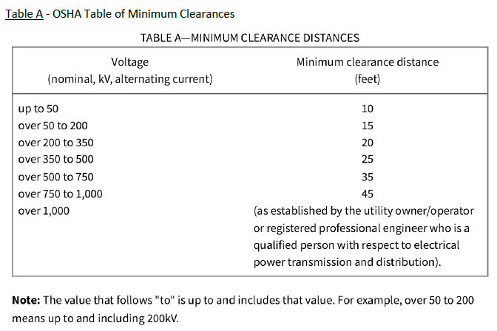  -The minimum vertical clearance for overhead power and communication lines  above the highway and approaches to the highway shall conform to the  current National Electrical Safety Code.  - Greater clearances shall be used when required by state or federal law,  regulation, code, or policy as summarized in Basic Clearance for the  Installation of Electric Supply and Communications Lines. This document  may be found in Table I.  - In all cases, facilities crossing over highways shall at no time be less than 22  feet above the high point of the travelled way.
Waterways | *8810.3400 - MN Rules Part | All waterways and lines of drainage shall remain operative.
Work Site Safety | *UTILITY ACCOMMODATION MANUAL-1706321-v1.PDF | The utility owner is responsible for securing the work site against any hazard to  workers, pedestrians, bicyclists, and the motoring public at all times until completion  of all work. The utility owner shall control all vehicles, equipment, and materials that  are in active use at the work site to assure consistently safe conditions.  - Utility hardware or equipment that is located at the work site but not in immediate use  should be stored in a safe location off the right of way. If this is not practical, the  hardware or equipment may be stored beyond the clear zone as close to the fence or  right of way line as possible.  - All vehicles used to conduct the work operation shall be equipped with conspicuously  visible roof-mounted high-intensity revolving or strobe lights. Vehicles and  equipment shall have their high intensity flashing lights (strobe or revolving) and  hazard warning lights operating just before and during work operations when they  are within the right of way.  - All workers (utility, MnDOT, contractor, etc.) must wear high visibility apparel (vest,  shirt, or jacket) at all times. Flag persons and workers must wear high-visibility pants  at all times during low light or night conditions. When workers are in an area that  does not require the use of a hard hat for head protection, they should wear a high visibility  for increased visibility. All high-visibility apparel shall comply with the  requirements in the Minnesota Manual on Uniform Traffic Control Devices.
Consult with OLM Utility Routing & Siting Coordinator on Control of Access | 8810.3300 Subp. 4 | Utilities along the interstate highways shall be located outside the control-of-access lines except as outlined below. Where the control-of-access lines coincide with the right-of-way lines, the utilities shall generally be located on private property. Where the control-of-access lines and right-of-way lines do not coincide, utilities may in general be located in the area between them. All utilities shall be serviced and maintained without access from the ramps, loops, and through traffic roadbeds. Utilities may be serviced from frontage roads and roads other than another interstate highway which cross either over or under the interstate highway. At aerial crossings of an interstate highway, supporting poles may be located on interstate highway right-of-way if they are a minimum of 30 feet beyond the shoulders of all through traffic roadbeds; however, in no event shall they be located in a median unless its width is 80 feet or more. Manholes and other points of access to underground crossings may be permitted on the interstate highway right-of-way only when located outside the shoulders of the through traffic roadbeds, loops, or ramps. The restrictions of this subpart shall not apply to utility lines which service facilities required for operating the interstate highway.  (1) Each State transportation department shall submit an accommodation plan in accordance with §§ 645.211 and 645.215 which addresses how the State transportation department will consider applications for longitudinal utility installations within the access control lines of a freeway. This includes utility installations within interchange areas which must be constructed or serviced by direct access from the main lanes or ramps. If a State transportation department elects to permit such use, the plan must address how the State transportation department will oversee such use consistent with this subpart, Title 23 U.S.C., and the safe and efficient use of the highways.
  7850.4400 - MN Rules Part
  7850.4100 - MN Rules Part
  According to 23 CFR § 645.209(c): Installations within freeways.
AASHTO Guide for Accommodating Utilities with highways and freeways 1st Editions May 2024:

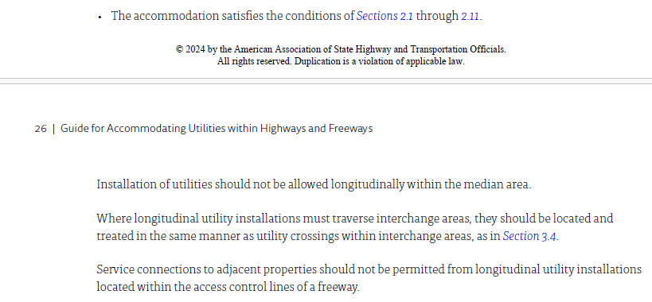

APPENDIX A
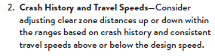
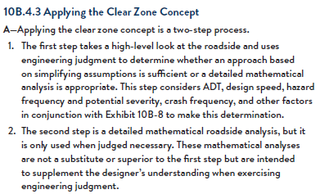
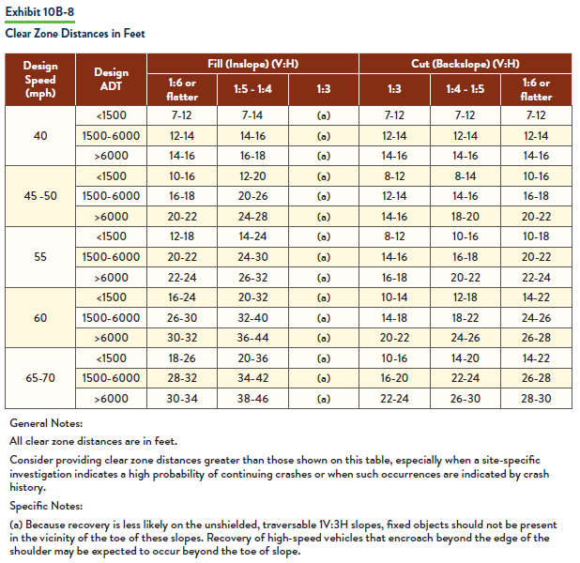
Reasons to increase clear zone width, refer to FDG for more details: