STATE OF MINNESOTA DISTRICT COURT

COUNTY OF RAMSEY SECOND JUDICIAL DISTRICT

Case Type: Other Civil
Court File # 62-CV-25-

______________________________________________

State of Minnesota, by Miguel Cabrera
and Shannon Cabrera, M.D.
COMPLAINT FOR DECLARATORY
Plaintiffs, AND
INJUNCTIVE RELIEF UNDER MERA
Minnesota Public Utilities Commission and (Minn. Stat. Ch. 116B)
Northern States Power d/b/a Xcel Energy, Inc.

Defendants.
______________________________________________

Plaintiffs, State of Minnesota by Miguel Cabrera and Shannon Cabrera, M.D. (hereinafter “Cabreras”), for their Complaint against Defendants Minnesota Public Utilities Commission and Xcel Energy, state and allege as follows:
- INTRODUCTION

- Miguel Cabrera and Shannon Cabrera, M.D. bring this Complaint for Declaratory and Injunctive Relief under the Minnesota Environmental Rights Act, Minn. Stat. §116B.03, and Minn. Stat. §116B.10, based on the Minnesota Public Utilities Commission’s Order routing Xcel Energy’s Minnesota Energy Connection radial transmission line over a new crossing of the Mississippi River when the Minnesota Department of Natural Resources repeatedly commented that it “strongly preferred” at least two other routes utilizing existing transmission crossings, avoiding a new crossing of the Mississippi River..
- On October 30, 2023, Xcel Energy submitted a revised application for its 180 mile long “Minnesota Energy Connection” transmission line, a radial line from southwest Minnesota’s Lyon County to the north and east, connecting to the Sherco substation.
- The stated purpose of this transmission line was to “preserve valuable interconnections rights” that would lapse if not utilized within a specific time frame after the closure of Xcel’s Sherco coal units.
- Three aspects of the project are novel, new to Minnesota, not previously considered by the Public Utilities Commission or any court. This transmission line is:
  - a private line owned exclusively by Xcel Energy, over which Xcel has exclusive decision making authority over generation interconnection;

  - a radial line where each end of the line does not have terminal endpoints connected to the grid and which requires voltage support to address the radial line’s voltage instability; and

  - an economic based project with the purpose of utilizing the “valuable interconnection rights” at the Sherco substation, interconnection rights which are only valid for a limited time after the closing, disconnecting, of Xcel’s Sherco coal units from that substation.

- On April 10, 2025, the Minnesota Public Utilities Commission (hereinafter “PUC”) granted a routing permit to Xcel Energy for its “Minnesota Energy Connection” transmission line on the “Blue Route,” the only route alternative that crosses the Mississippi River in a location with no existing river crossing.
- Plaintiffs Miguel Cabrera and Shannon Cabrera, M.D. are also aggrieved parties as a part of this crossing traverses their property on the Mississippi River shoreline:
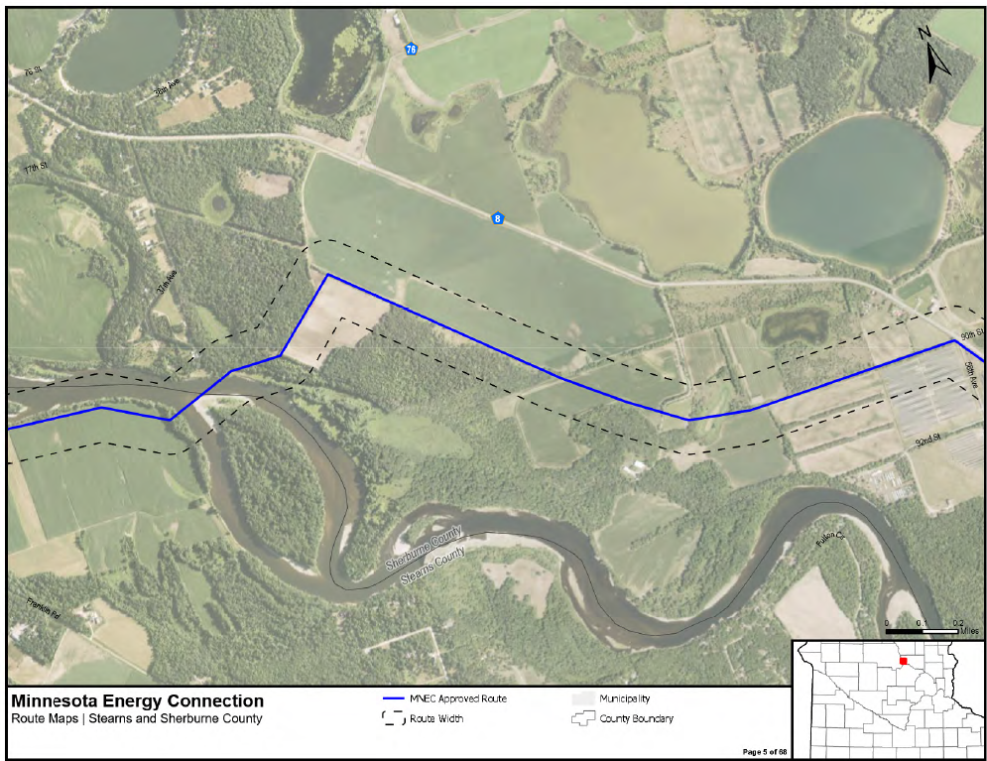
PUC Order, Map 5 of 60, pdf p. 67 of 140, filed June 11, 2025 20256-219826-01.
- The segment of the Blue Route at issue is a 3.2 mile section of the 180 mile transmission line route, from where on the west, Route Segment 246 heads north and Route Segment 258 heads south, and then extends to the southeast to where each intersects the Blue Route:
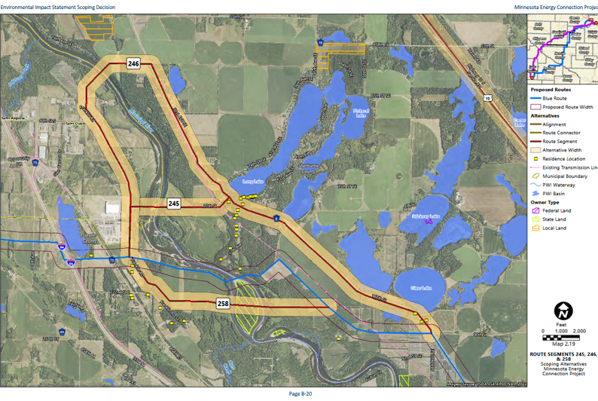
- The map above shows the Blue Route alignment crossing directly over the Cabreras’ home, the yellow dot crossed by the red “alignment” line. Id.
- This Complaint focuses on the routing of the Minnesota Energy Connection transmission line over the Mississippi River utilizing the “Blue Route” and a new crossing, and the failure of the Public Utilities Commission (hereinafter “PUC”) to consider and give great weight to the environmental expertise of the Minnesota Department of Natural Resources (hereinafter “DNR”) and to the DNR’s specific Comments made in multiple filings stating that it “strongly preferred” two alternative routes that would use existing river crossings and not a new crossing due to specifically named likely impacts.
- PARTIES
- The Cabreras are aggrieved landowners who live in Sherburne County along the Mississippi River at the location chosen by Xcel Energy and the Public Utilities Commission for the Minnesota Energy Connection transmission line’s crossing of the Mississippi River. Shannon and Miguel Cabrera are natural persons as defined by the Minnesota Environmental Rights Act (hereinafter “MERA”), Minn. Stat. §116B.02, Subd. 2, and parties under MERA. Minn. Stat. §116B.03, Subd. 1.
- The Cabreras participated in the routing process, making comments orally and in writing, and proposed alternate routes for the Mississippi River crossing that were evaluated in the Draft and Final Environmental Impact Study, then filed a Motion for Reconsideration after the permit was issued, which was denied without discussion. The Cabreras have exhausted their administrative remedies. The statutory appeal period has elapsed. Minn. Stat. §116B.10, Subd. 1.
- Defendant Minnesota Public Utilities Commission (hereinafter “PUC”) is the quasi-judicial entity with authority to route transmission in the state of Minnesota. Its mission is “to improve the lives of all Minnesotans by ensuring safe, reliable, and sustainable utility services at just and reasonable rates.” Defendant Public Utilities Commission is a party as provided by MERA. Minn. Stat. §116B.03, Subd. 1.
- Defendant Northern States Power Company, a Minnesota corporation, doing business as Xcel Energy, is the Applicant that applied for and was granted a Route Permit by the Minnesota Public Utilities Commission for approval to construct the Minnesota Energy Connection Project in Sherburne, Stearns, Kandiyohi, Wright, Meeker, Chippewa, Yellow Medicine, Renville, Redwood, and Lyon counties in Minnesota. Defendant Northern States Power Company, doing business as Xcel Energy, is a party as provided by MERA. Id.
- STANDING, JURISDICTION AND VENUE
- The Cabreras are natural persons, aggrieved by the routing Order and permit, residing in the state within the meaning of the Minnesota Environmental Rights Act. Minn. Stat. §116B.02, Subd. 2, and as used in Minn. Stat. §116B.03, Subd. 1 and Minn. Stat. §116B.10, Subd.1.
- The Cabreras have standing because every natural person residing in Minnesota has the right to sue to protect the natural resources of this state and to bring civil action against anyone, including corporations and governmental agencies, to compel them to act and to ensure that they do not impair or destroy the state’s natural resources. State of Minnesota by Smart Growth Minneapolis, 954 N.W.2d at 596; Corwine v. Crow Wing County, 244 N.W.2d 482, 490-91 (Minn. 1976); Krmpotich v. City of Duluth, 483 N.W.2d 55, 56 (Minn. 1992); see also Minn. Stat. §116B.03, Subd. 1; Minn. Stat. §116B.10, Subd.1.
- “[E]ach person is entitled by right to the protection, preservation, and enhancement of air, water, land, and other natural resources within the State.” Minn. Stat. § 116B.01.
- The Public Utilities Commission is an agency of the state, and this Court has jurisdiction of the claims for declaratory and equitable relief as asserted under the Minnesota Environmental Rights Act. Minn. Stat. §116B.10, Subd. 1.
- Northern States Power, d/b/a as Xcel Energy proposed the Minnesota Energy Connection transmission project and chose as its preferred route the 3.2 mile segment of the Blue Route crossing of the Mississippi River, and submitted its application to the Public Utilities Commission in St. Paul, which approved the route and granted a permit on April 10, 2025. The
- Ramsey County is the home of the Public Utilities Commission, where the cause of action arose through the Commission’s consideration and granting of a permit for this transmission route’s crossing of the Mississippi River, and thus, venue for this action is proper in this court under Minn. Stat. §116B.03, Subd. 4.
- This Complaint is a challenge to the 3.2 mile Mississippi River crossing segment within the 180 mile transmission line routing permit issued by the Public Utilities Commission, and the appeal time has elapsed. Minn. Stat. §116B.10, Subd. 1.
- TRANSMISSION LINE IS LIKELY TO CAUSE ENVIRONMENTAL DAMAGE AND PERMIT INADEQUATE TO PREVENT HARMS

- The construction and operation of this transmission project, as permitted by the PUC, is likely to cause pollution, impairment, or destruction," under Minn. Stat. § 116B.03, Subd. 1, broadly defined under Minn. Stat. § 116B.02, subd. 5 as inclusive of "any conduct which…is likely to materially adversely affect the environment."
- MERA codifies the state's paramount concern for the protection of its air, water, land and other natural resources from pollution, impairment, or destruction. Minn. Stat. § 116B.04 (b) (1985); State Ex Rel. Swan Lake Area Wildlife Ass'n v. Nicollet County Bd. of County Commissioners, 799 N.W.2d 619 (Minn. App. 2011).
- A plaintiff's "prima facie showing" has two requirements. State by Archabal v. County of Hennepin, 495 N.W.2d 416, 421 (Minn. 1993). "First, the plaintiff must show the existence of a protectable natural resource." Id. Second, the plaintiff must show the "pollution, impairment or destruction"- as defined in Minn. Stat. § 116B.02, subd. 5 above - of that "natural resource" which is likely to be caused by the "conduct at issue." Id.
- "Natural resources" are broadly defined under MERA:

"Natural resources" shall include, but not be limited to, all (1)] mineral, [(2)] animal, [(3)] botanical, [(4)] air, [(5)] water, [(6)] land, [(7)] timber, [(8)] soil, [(9)] quietude, [(10)] recreational and [(11)] historical resources. [(12)] Scenic and [(13)] esthetic resources shall also be considered natural resources when owned by any governmental unit or agency.

Minn. Stat. §116B.02, subd. 4 (emphasis and bracketed information added).

- “Shall” is mandatory." Minn. Stat. § 645.44, subd. 16.

- In MERA cases, the courts have broadly defined "natural resources." State by Archabal, 495 N. W.2d at 418 (Armory is a protected natural resource); State by Powderly v. Erickson, 285 N.W.2d 84, 88 (Minn. 1979) (historical row houses are a protected natural resource): Minnesota Public Interest Research Group v. White Bear Rod & Gun Club, 257 N.W.2d 762, 770 (Minn. 1977) (lakes and wetlands are "natural resources"); State by Fort Snelling State Park Ass' v. Minneapolis Park & Recreation Ba, 673 N.W.2d 169, 174-75 (Minn. App. 2003) (historical polo grounds on Fort Snelling site are a protected natural resource); State ex rel. Wacouta Twp. v. Brunkow Hardwood Corp., 510 N. W.2d 27, 29 (Minn. App. 1993) ("bald eagles and the trees in which they roost are a natural resource within the scope of MERA" and that “MERA's definition of natural resources is presumed to be broad”'); State by Drabik v. Martz, 451 N.W.2d 893, 896-97 (Minn. App. 1990) (scenic and esthetic resources impacted by proposed radio tower protected natural resource).
- This action against the state challenges the route permit issued for Xcel Energy’s Minnesota Energy Connection transmission line under both Minn. Stat. §116B.03 and Minn. Stat. §116B.10. The permit was granted at the Commission’s April 10, 2025 Agenda meeting, and the written order was filed on eDockets on June 11, 2025. Notice of the Permit Decision was published in the EQB Monitor and the State Register on September 9, 2025. The applicable statutory appeal period has elapsed. Minn. Stat. §116B.10, Subd. 1.
V. THE LAW OF ROUTING THIS TRANSMISSION LINE

- Minnesota’s law governing the routing of transmission changed significantly in the 2024 legislative session. Because this application was made prior to these changes, which are not retroactive, Minnesota Statutes ch. 216E, the Power Plant Siting Act, and Minnesota Rules 7850, are the statutes and rules in effect at that time of application and which govern routing process and decisions.
- The Public Utilities Commission is responsible for regulating utilities, and in 2005, the legislature transferred the Power Plant Siting Act, Minn. Stat. ch. 216E, responsibility for routing transmission from the Environmental Quality Board to the PUC. Minn. Stat. §216E.02, Subd. 2. The Minn. R. ch. 7850 has remained unchanged.
- The PUC as regulator has long been responsible for economic regulation, and projects are evaluated and granted a Certificate of Need based on statutory criteria and associated rules. Minn. Stat. §216B.243; Minn. R. ch. 7849.
- The Commission, through a Consent Order, “[a]uthorized use of the informal review process for the Certificate of Need application under Minn. R. 7829.1200.” PUC Consent Order, May 2, 2023.
- Responsibility for routing and siting was transferred by the legislature to the PUC in 2005. Minn. Stat. §216E.02, Subd. 2. The Department of Commerce is to handle Environmental Review. Minn, Stat. §216E.03, Subd. 5.
- “The Minnesota Department of Commerce and its predecessor agencies have protected consumer interests and ensured a fair and competitive marketplace in our state.” Per that website, “commerce” is the focus, and environmental protection, project review, and impact analysis is not an area of expertise:
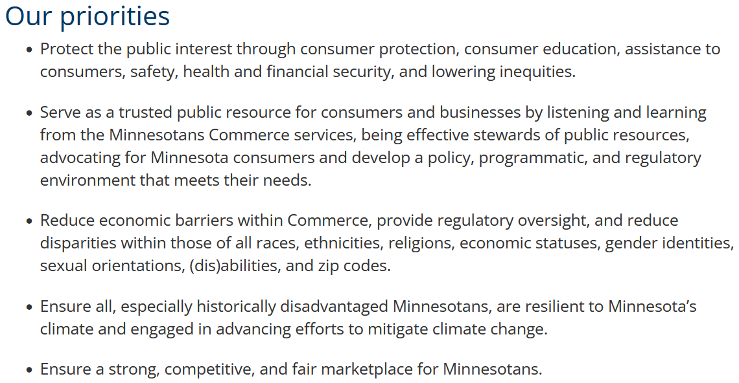

- Early in review of this transmission line’s Certificate of Need and Route applications, Xcel Energy requested exemption from many of the Certificate of Need data requirements, and in another Consent Order was granted exemptions on June 28, 2022, specifically:
Approved the following exemptions from the certificate of need application data requirements conditioned on Xcel Energy providing alternative data:

  - 7849.0260, subp. A (3) and C (6)—granted the requested exemption with the provision of the proposed alternative data;

  - 7849.0260, subp. B (4) and B (8)—granted the requested exemption;

  - 7849.0270—granted the requested exemption with the provision of the proposed alternative data and require Xcel to provide updated demand and energy forecasting data;

  - 7849.0280, subp. B through I—granted the requested exemption with the provision of the proposed alternative data and required Xcel to state any updates to the quantity of new generation needed based upon the updated demand and energy forecasting provided under Minnesota Rules 7849.0270;

  - 7849.0290, subp. F—granted the proposed exemption and required Xcel to present a summary of the conservation information in the IRP and CIP filings rather than replicate the data in the instant docket;

  - 7849.0300 and 7849.0340—granted the requested exemption with the provision
of the proposed alternative data; and

g. 7849.0330, subp. G—granted the requested exemption with the provision of the proposed alternative data.

PUC Consent Order, p. 1-2, June 28 2022, online at 20226-186932-01.

- The Minnesota Department of Natural Resources is charged with protection of natural resources and has significant environmental expertise.
The mission of the Minnesota Department of Natural Resources (DNR) is to work with Minnesotans to conserve and manage the state's natural resources, to provide outdoor recreation opportunities, and to provide for commercial uses of natural resources in a way that creates a sustainable quality of life.

More specifically:

The Minnesota Department of Natural Resources works to integrate and sustain the interdependent values of a healthy environment, a sustainable economy, and livable communities. DNR’s integrated resource management strategy shares stewardship responsibility with Minnesotans and partners to manage for multiple interests. DNR protects the state’s natural heritage by conserving the diversity of natural lands, waters, and fish and wildlife that provide the foundation for Minnesota’s recreational and natural resource-based economy (M.S. 84, M.S. 97A). DNR manages natural lands such as forests, wetlands, and native prairies; maintains healthy populations of fish and wildlife; and protects rare plant and animal communities throughout the state. DNR manages the state’s water resources, sustaining healthy waterways and ground water resources. DNR provides access to enrich public outdoor recreational opportunities, such as hunting, fishing, wildlife-watching, camping, skiing, hiking, biking, motorized recreation, and conservation education through a state outdoor recreation system that includes parks, trails, wildlife management areas, scientific and natural areas, water trails, and other facilities (M.S. 86A). DNR supports natural resource-based economies, managing state forest lands for multiple forest values (M.S. 89), ensuring the maximum long-term economic return from school trust lands (M.S. 127A), and providing other economic opportunities in a manner consistent with sound natural resource conservation and management principles.

- A fundamental case governing environmental considerations in the routing of transmission lines is People for Environmental Enlightenment and Responsibility (PEER), Inc. et al, petitioners, Appellants, v. Minnesota Environmental Quality Council, etc., Respondent, Northern States Power Company, Respondent, 266 N.W. 2d 858, Minn. 1978).
- The PEER decision focuses on Minnesota’s policy of nonproliferation of transmission routes to protect natural resources, the premise that protected natural resources are non-compensible, whereas most homes are compensable, and that a balancing of compensable versus non-compensible resources is necessary. The PEER court put it clearly:
An HVTL routing that impairs, pollutes, or destroys protected natural resources cannot be approved if there is a prudent and feasible alternative route available.

Id., p. 864. Further:

Because Minnesota is committed to the principle of nonproliferation… the fact that the utilization of Route 3 would require the condemnation of a number of homes is not, in and of itself, sufficient to overcome the law’s preference for containment of powerlines.

Id.
- The court’s presumption is that a transmission line would cause environmental damage
where ever it was routed, it would cause some damage to natural resources and the environment.
Id., p.867, fn. 12, 868.
- At that time, the transmission line exclusion criteria was very specific:

"(2) Transmission Line Avoidance Areas. In addition to exclusion areas, the following land use areas shall not be approved for HVTL routes when feasible and prudent alternatives with lesser adverse human and environmental effects exist. Economic considerations alone shall not justify approval of avoidance areas. Any approval of such areas shall include all possible planning to minimize harm to these areas. HVTL avoidance areas are: national parks; national historic sites and districts and natural landmarks; national monuments; national wildlife refuge areas; national wild, scenic, and recreational riverways; state wild, scenic, and recreational rivers and their land use districts; state parks; state registered historic sites; state historic districts; Nature Conservancy preserves; state scientific and natural areas; county parks; metropolitan parks; designated state and federal recreational trails; designated state canoe and boating routes; and any other area designated a transmission line avoidance area by the Council.

Id., p. 869 (emphasis added).

- The PEER decision was in 1978, and much has changed since then… but some avoidance criteria remain:

PROHIBITED ROUTES.

Subp. 2. Parks and natural areas.
No high voltage transmission line may be routed through state or national parks or state scientific and natural areas unless the transmission line would not materially damage or impair the purpose for which the area was designated and no feasible and prudent alternative exists. Economic considerations alone do not justify use of these areas for a high voltage transmission line.
Minn. R. 7850.4300.
- The purpose of Mississippi River’s Wild and Scenic and Recreational designation is to conserve natural resources:
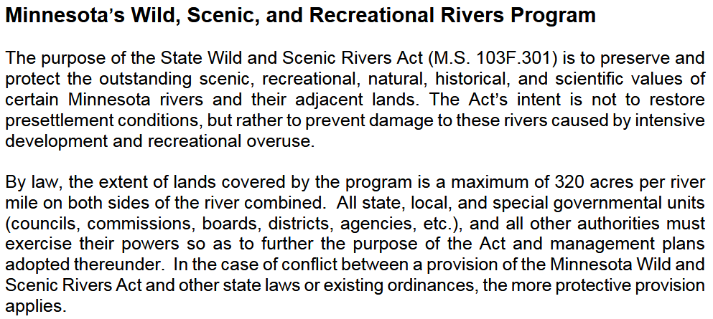
Management Plan, Mississippi Scenic Riverway, p 11 (2004).
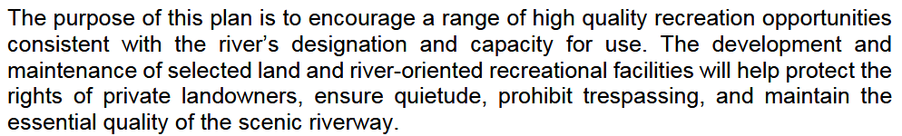
Id., p. 76.
- The siting hierarchy is that the routing of transmission must comply with “state goals to conserve resources, minimize environmental impacts, and minimize human settlement and other land use conflicts and ensures the state's electric energy security through efficient, cost-effective power supply and electric transmission infrastructure.” Minn. R. 7850.4000.
- The Blue Line route was Xcel Energy’s preferred route, proposed by Xcel in its routing application, studied in the Environmental Review process of scoping, the Draft EIS and Final EIS, the ALJ’s Recommendation, and ultimately the decision and Order of the Public Utilities Commission adopting the Recommendation of the ALJ, with modifications.
- CONSIDERATION OF MISSISSIPPI RIVER PROTECTIONS ARE INADEQUATE

- In the introduction to Region G, the FEIS states, “Aesthetic impacts can also be minimized by following existing transmission line ROW where elements of the built environment already define the viewshed and the addition of an additional HVTL would have an incremental impact.” FEIS, Region G, p. 411.
- The Region G introduction goes on to describe the Mississippi Scenic Byway, the Wild and
Scenic River, and clearly states that the Blue Route impacts would be “significant.”
The Mississippi River is a designated state water trail, which promotes water recreation (Minnesota Statutes § 85.31), and a wild and scenic river (Minnesota Statutes § 103F.305), which falls under certain protections put in place in
Minnesota’s 1973 Wild and Scenic Rivers Act. As discussed in Section 12.6.9, Route Segment G1 (Blue Route) would parallel the Mississippi River (approximately 0.8 mile), which would increase the intensity of the aesthetic impact at this location. At the scenic byway location for Route Segments G1 (Blue Route) and G2, no existing transmission lines are present but existing development is present north of the anticipated alignments. Similarly, there are no existing transmission lines present where Route Segments G1 (Blue Route) and G2 cross the Mississippi River and trees would need to be removed from the shoreline (Map N.205). Given the lack of development at the watercourse crossing, aesthetic impacts would be anticipated to be significant.

FEIS, Region G, p. 411.

- That section later states, “Where the route segments cross the river, they would be parallel an existing transmission line ROW,” with no identification of the crossing or existing transmission line ROW the statement refers to. Id.
- In “Land-Use and Zoning,” the FEIS fails to address either the Stearns County or Sherburne County’s Shoreland Districts, protective of the Mississippi River shoreland. These District Overlays were raised by the DNR in its comments as a factor for consideration, and were not carried through into the FEIS:
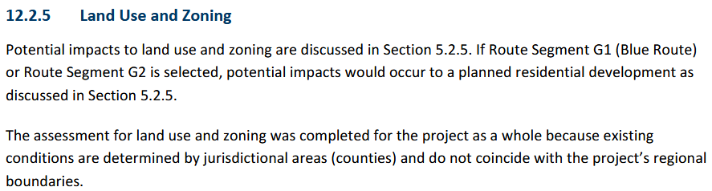
FEIS, Land-Use and Zoning, Section 12.2.5, p. 418; see DNR July 10 2023 Comment, p. 2, noting to “Please be aware that in Sherbuurne County, most of the Mississippi River bank within the WSR [Wild and Scenic River] district is also in a Bluff Impact Zone and may be subject to additional restrictions.”
- The EIS disregards and discounts the Mississippi River Crossing in narrative and charts:
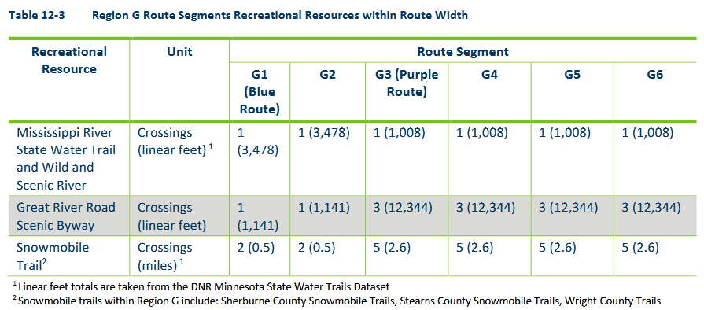
FEIS, Section 12.2.8 Recreation, p. 419.
- The FEIS section on Recreation does mention the Mississippi and states that information can be found in FEIS Section 12.2.1, but that is only regarding aesthetics, and makes no reference to other sections of the FEIS with information about the Mississippi River. The FEIS “Environmental” Section 12.1 makes no mention of the Mississippi and its environmental protections. From the Recreation section:
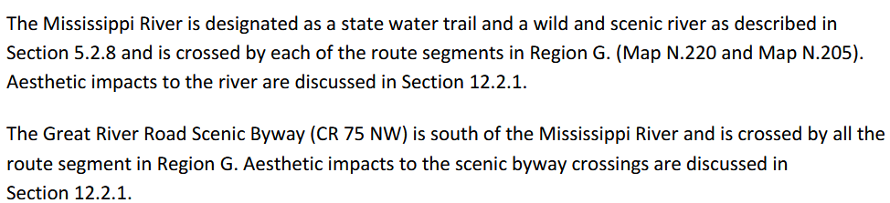
FEIS, p. 419.
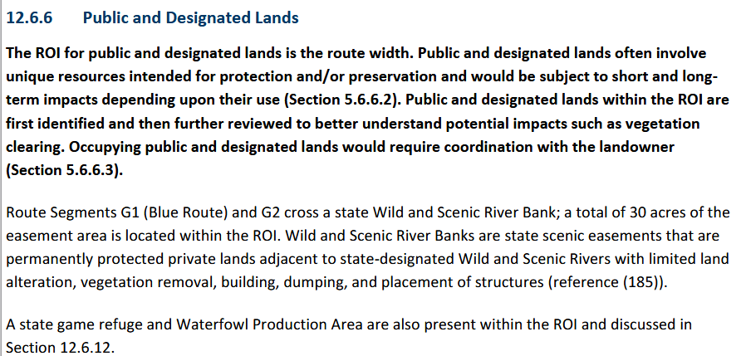
FEIS, p. 429.
- In a comparison of Route segments 245 and 246, crossing the Mississippi, the river is not even mentioned in the narrative or the summary:
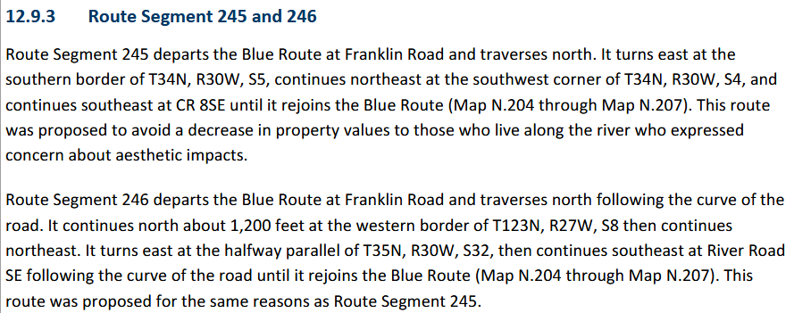
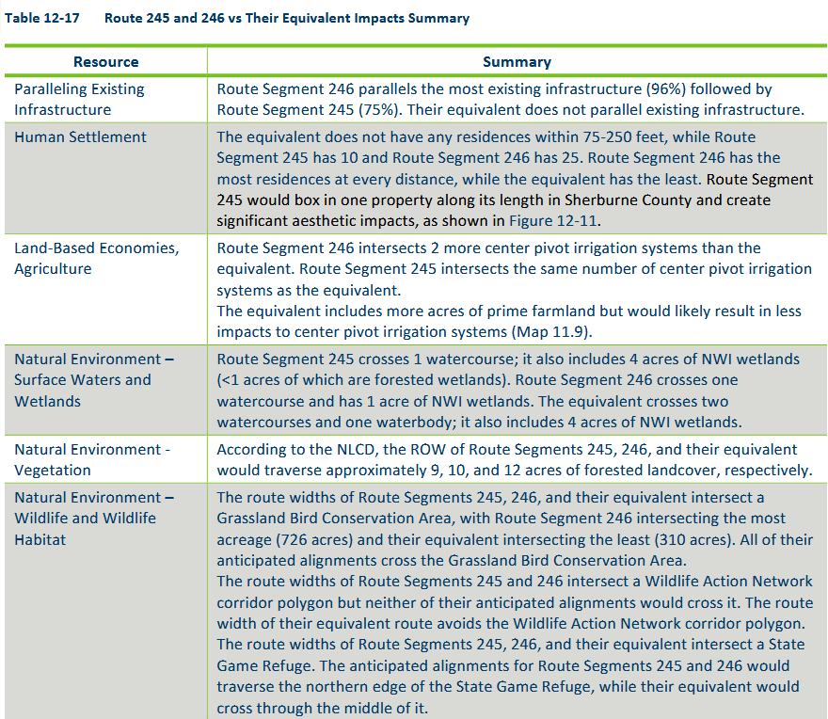
FEIS, Region 6, Segment alternatives for crossing Mississippi p. 448-449.
- ERRONEOUS PRIORITIZATION OF RESIDENCES AS ROUTING CRITERIA
- At each step, the choice of route stressed, counted, and relied on the number of residences near the proposed transmission corridor.
- For example, in its consideration of various routing criteria, Xcel’s application states that “To minimize impacts on the environment and affected landowners, the Applicant identified areas to avoid within the Routing Study Area.” Xcel lists “residences” at the top of the list.
- Amongst the application’s 72 references to residences, a section of the application addresses residences along the routes, and Xcel notes that there are no homes within either proposed route right of way and there would be no displacement of residents:
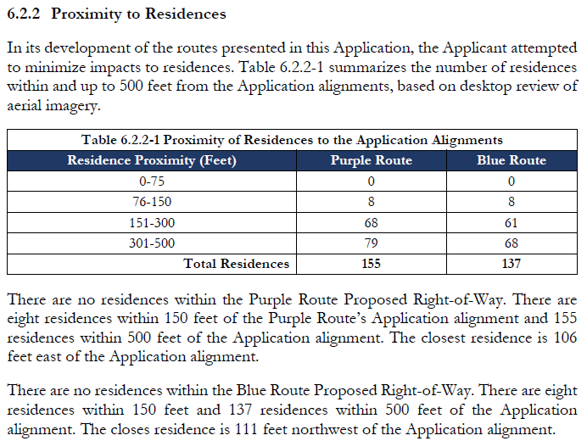
Id., p. 79. This chart shows that no homes would be within the right of way and none would be displaced. This chart also is not weighted in any way showing distance from right of way and extent of impacts, these are just numbers on a chart, with homes up to 500 feet away receiving the same consideration as ones 76 feet from the right of way, as one number in the total of residences.
- The emphasis on residences was a primary reason for Xcel’s preference of the Blue Route crossing of the Mississippi:
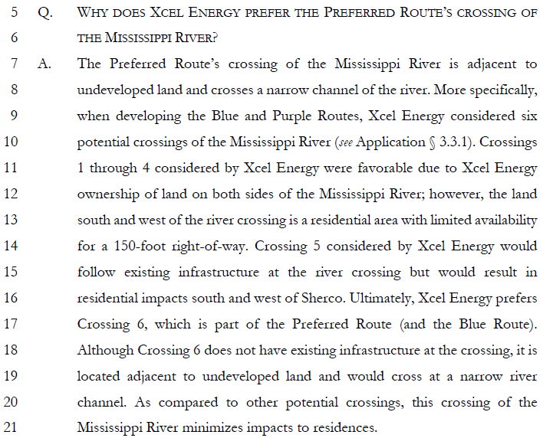
Hearing Exhibit Xcel-16, Direct Testimony of Langan, p. 17.
- This misplaced emphasis was carried through to the Recommendation of the ALJ, here residences and residential impacts take a high priority, citing Xcel’s Langan’s testimony.
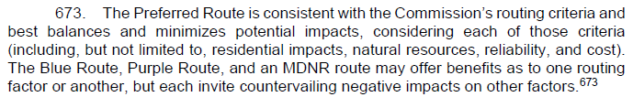
- Also citing Langan’s Testimony, the ALJ noted that, “378. Xcel Energy indicated that avoiding displacement and minimizing impacts on existing residences was a key consideration in its routing process.”
- Consistent with the MERA definition of “natural resources,”, the Mississippi River, one of the longest rivers in the United States, is designated as a state Wild and Scenic River in this area, and is “Section 8” of the Mississippi River State Water Trail, with a campsite on a small peninsula directly south of the island that the transmission line would cross.
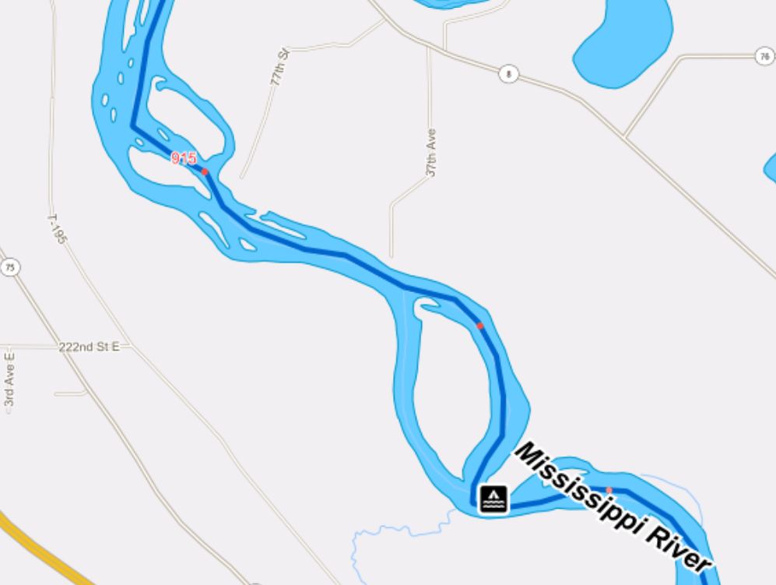
- The area of the crossing is a bald eagle nesting and foraging area, a center for non-motorized recreational watercraft, tourism, and it is protected by county bluffland/shoreland ordinances on both sides of the river.
- This area of the Mississippi River is unquestionably a natural resource to be protected. See Minn. Stat. §103F.315. As a state Wild and Scenic River and Section 8 of the Minnesota Water Trail, with the local shoreland protections on both sides of the river, under the rules, transmission is prohibited. Minn. R. 7850.4400.
- CABRERAS DEMONSTRATE LIKELY DISTRUCTION AND IMPAIRMENT
- In this civil action, Cabreras must show that the conduct of the defendants, the Public Utilities Commission and Xcel Energy, is likely to cause pollution, impairment, or destruction of natural resources located within the state. Minn Stat. §116B.03, Subd. 1.
- The courts have also, consistent with the broad definition of "pollution, impairment, or
destruction" under Minn. Stat. § 116B.02, subd. 5, broadly construed the term "materially adverse
effects [on]... the environment". Citizens for a Safe Grant v. Lone Oak Sportsmen's Club, Inc., 624 N.W.2d 796, 805 (Minn. App. 2001) (expressing the broad nature of "materially adverse affects" provision of MERA by "recognizing that there are instances when environmental regulations may not keep up with changing conditions");State by Drabik, 451 N. W.2d at 897 (concluding that MERA is "broad enough" to prevent materially-adverse effects on scenic and aesthetic resources from installation of radio tower on private property); Minnesota Public Interest Research Group, 257 N.W.2d at 781 (applying MERA as "a far-reaching legislative enactment").
- Courts will consider the following five factors in determining whether the "conduct at issue" "is likely to materially adversely affect the environment":
  - The quality and severity of any adverse effects of the proposed action on the natural resource affected;

  - Whether the natural resources affected are rare, unique, endangered, or have historical significance;

  - Whether the proposed action will have long-term adverse effects on natural resources, including whether the affected resources are easily replaceable (for example, by replanting trees or restocking fish);

  - Whether the proposed action will have significant consequential effects on other natural resources (for example, whether wildlife will be lost if its habitat is impaired or destroyed); and

  - Whether the affected natural resources are significantly increasing or decreasing in number, considering the direct and consequential impact of the proposed action.

State by Schaller v. County of Blue Earth, 563 N.W.2d 260, 267 (Minn. 1997); White v. Minnesota Dep' of Natural Resources, 567 N.W.2d 724, 738 (Minn. App. 1997).
- In this case, specifically this section of the Wild and Scenic Mississippi River and district, this section of the Mississippi River State Water Trail, the protected shoreline and bluffland, viewshed of the natural area, vegetation removal, tree clearing along the river, erosion of the river bank, fragmentation and impacts to Sites of Biodiversity Significance, bird impacts, impairment of outstanding scenic, recreational, natural, historic, and scientific attributes of the area, and to avoid the braided section and the nearby island. See Minn. Stat. §116B.04, Subd. 2.
- Stearns County has a protective Scenic River District and Island Preservation District:
9.13 Scenic River District (SR District)
9.13.1 Purpose The purpose of the Scenic River District is to protect and preserve the scenic, recreational and natural values of the Mississippi River by controlling development within a specified river corridor consistent with Minnesota Rules, parts 6105.0800-6105.0870 and Minnesota Rules, parts 6105.0010-6105.0250; or successor rules.

9.16 Island Preservation District (IP District)
9.16.1 Purpose The purpose of this district is to provide for the preservation and management of islands that are located within the County.

… and …

10.2 Shoreland Overlay District
10.2.1 Purpose The purpose of the Shoreland Overlay District is to protect and enhance the quality of surface waters by promoting the wise utilization of public waters and related land resources. All land within Shoreland located in Stearns County is hereby designated as Shoreland Overlay District and the standards set forth in this Section shall regulate development and other activities within the Shoreland Overlay District.

This Overlay District covers the Stearns County area of the Blue Route Mississippi River Crossing:

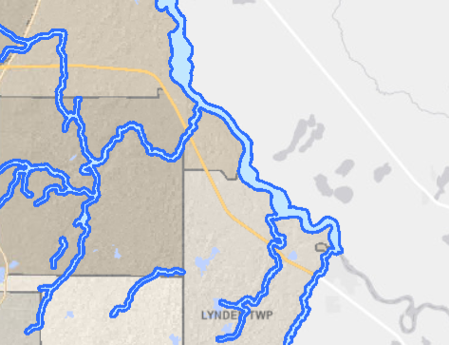
- The Stearns County GIS also shows that the area is within the Mississippi River floodplain:
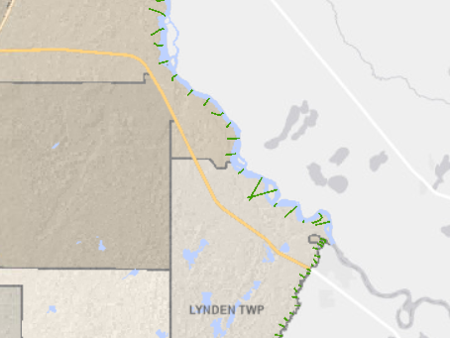
- The Sherburne County side of the river is also within the county’s Shoreland Protection District
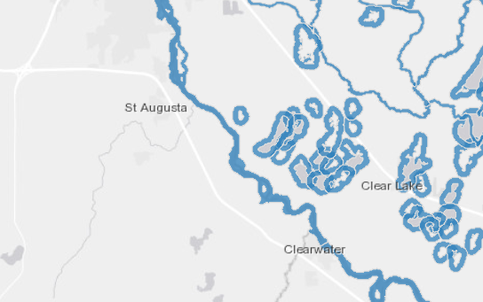
- In their action against the state, the Cabreras can also show the inadequacy of the permit issued by the Public Utilities Commission to protect, as above, this section of the Wild and Scenic Mississippi River and district, this section of the Mississippi River State Water Trail, the protected shoreland and bluff land, viewshed of the natural area, vegetation removal, tree clearing along the river, erosion of the river bank, fragmentation and impacts to Sites of Biodiversity Significance, bird impacts, impairment of outstanding scenic, recreation and tourism, natural, historic, and scientific attributes of the area, and to avoid the braided section and the nearby island. Minn. Stat. §116B.10, Subd. 2.
- The Cabreras shall also demonstrate that, in light of affirmative defense options available to Defendants, that there were reasonable and prudent route alternatives available and that routing using a new crossing of the Mississippi River, the conduct at issue, is not consistent with and reasonably required for promotion of the public health, safety, and welfare in light of the state's paramount concern for the protection of its air, water, land and other natural resources from pollution, impairment, or destruction.
- The Cabreras shall also show that the purpose of this transmission project is economic, to allow Defendant Northern States Power d/b/a Xcel Energy, “to reuse Xcel Energy’s existing and valuable interconnection rights at the Sherco Substation resulting from the retirement of the three Sherco coal-fired generators.” Hearing Exhibit Xcel-3, Route Permit Application (valuable interconnection rights):
  - In its 2020-2034 Upper Midwest Integrated Resource Plan (IRP) filing (MPUC Docket No. E002/RP-19-368), Xcel Energy proposed to construct two 345 kV transmission lines (gen-ties) between Lyon County and the existing Sherco Substation to acquire needed renewable energy resources and also to reuse Xcel Energy’s existing and valuable interconnection rights at the Sherco Substation resulting from the retirement of the three Sherco coal-fired generators. p. 3

  - The Project enables Xcel Energy to reuse its valuable and existing transmission interconnection rights (approximately 2,000 MW total). These rights will be retained pursuant to the Federal Energy Regulatory Commission (FERC) Electric Tariff, Midcontinent Independent System Operator, Inc. (MISO) Attachment X. The FERC has granted current generation owners the right to reuse the associated transmission interconnection for new generation at those sites as the old generation retires as part of the energy transition from carbon-based fuels to renewable energy. Id.

  - The proposed Project will connect new renewable energy generation to the electrical grid as coal operations cease at Sherco and will allow Xcel Energy to reuse its valuable and existing transmission interconnection rights. Interconnection rights are a valuable asset in part because the regional transmission grid is congested. p. 17.

  - As discussed in the CN application, the proposed Project is needed to ensure that sufficient energy resources could be interconnected to the Company’s system in the timeframe needed to meet Xcel Energy’s resource and capacity requirements, as well as achieve clean energy goals cost effectively and to make efficient reuse of the Company’s interconnection rights at the Sherco Substation after the coal units retire. p. 20.

  - During the IRP proceeding, Xcel Energy proposed a plan to connect to the required wind and solar resources. The plan requires two 345 kV transmission lines between Lyon County and the existing Sherco Substation. Connecting at the Sherco Substation allows reuse of Xcel Energy’s existing and valuable interconnection rights. In the April 2022 IRP order, the Commission directed Xcel Energy to begin proceedings to obtain a CN and Route Permit for the two 345 kV transmission lines. p. 22.

- The application notes that “[a]dditional details about reuse of existing interconnection rights and the estimated costs of MISO interconnection are provided in Xcel Energy’s CN application, filed under Docket No. E002/CN-22-131. Id., p. 18. Much of the language is word-for-word that in the Routing application. Id., p. 18. See Certificate of Need Application, p. 17 (The only way that Xcel Energy can retain its interconnection rights at Sherco is to directly connect Xcel Energy-owned generation to the Sherco Substation via a single-user generation tie line, like those proposed with this Project.); p. 71 (The identified need is to interconnect new generation to the Sherco POI… Further, to be able to utilize existing transmission interconnection rights at the Sherco POI, the proposed connection must be a radial connection per the MISO FERC Electric Tariff, Attachment X. Existing transmission lines are not radial. Therefore, upgrading existing transmission lines cannot meet the identified need.)
- The Integrated Resource Plan referenced above is the origin of the “need” claim for this transmission project and attempt to avoid Certificate of Need review for the project. In discussing the “valuable transmission interconnection rights” on which this project is based, the Certificate of Need application cites the Integrated Resource Plan (IRP).
- Initially the transmission line was to equal the 1,996MW interconnection rights at the Sherco substation, and then it was upped to a double circuited line with 4,000MW capacity.
- The cost of this project stated in the Certificate of Need application of May, 2023, was $1.14 billion.
- In testimony of Joseph Samuel, as of September 6, 2024, it was between $1,274 and $1.302 billion. One year later, as of a September 5, 2025 filing, the cost estimate has been updated to $1.367 billion, “due to Federal tariffs, additional route length and complexity, and real estate acquisition.” Xcel notes that material costs will fluctuate, and that “[t]he dynamism of the tariff risk is too uncertain to predict with reasonable certainty.” Id.
- This cost of this privately owned and operated radial transmission line, interconnecting Xcel owned projects interconnected, updated to $1,367 billion, and likely more, will be borne by the Xcel Energy ratepayers.

- CROSSING THE MISSISSIPPI AT A NEW LOCATION, RATHER THAN UTILIZING AN EXISTING LOCATION, WILL LIKELY MATERIALLY HARM NATURAL RESOURCES

- The Comments of the DNR laid out the likely impacts in detail. See Hearing Record, Ex. EERA-5, DNR Scoping Comments, February 21, 2024, p. 183-221 of Commerce-EERA group of Comments.
- These DNR Comments were not made an independent part of the record, and agency Comments were not identified in the “Combined Hearing Exhibit List.” Instead, these Comments were entered in a jumble of all the Comments received, with 15 links to batches of “Public Scoping Comments” labeled EERA-4. The DNR’s multiple Comments are within eDocket Document ID”20243-204514-03, pages 183-220 of the 227 page “Combined Hearing Exhibit List” filing.
- Xcel states that it met with the DNR three times before filing its application, December 19, 2022; March 16, 2023; and May 24, 2023. There is no documentation in the record regarding those meetings. ALJ Recommendation, Finding of Fact 239, disclosing meetings.
- In its application, Xcel admits that in the first written statement, “The MNDNR commented in a July 10, 2023 letter that ‘The DNR strongly prefers a route that utilizes existing crossings over the Mississippi River, especially within a wild and scenic river (WSR) district.’” Xcel Hearing Exhibit Xcel-2, Route Permit Application, p. 37. The DNR’s comment further states that “[o]f the route options provided, the only existing crossing is within Wright County. We would prefer this alternative.” Id. This map depicts the Purple Route crossing of the Mississippi River:
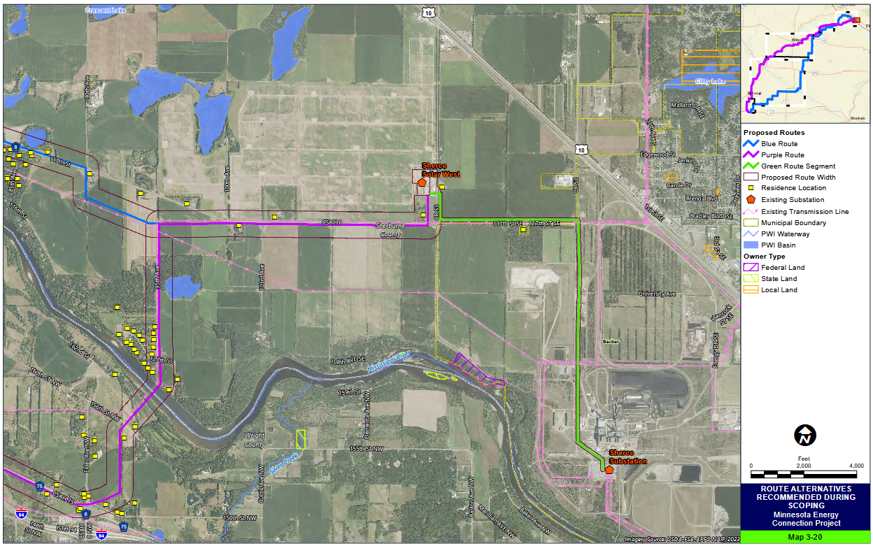
FEIS, Map 3-20, p. 22 of 67, “Map 1-8,” online at eDockets 20251-214220-02.
- Additional crossings were added in the Scoping Decision for the EIS.
- In Scoping Comments, the DNR again reiterated its preference of the Purple Route to utilize an existing crossing and avoid a new crossing. In this Comment, the DNR provided more detail of environmental issues regarding the Blue Route:
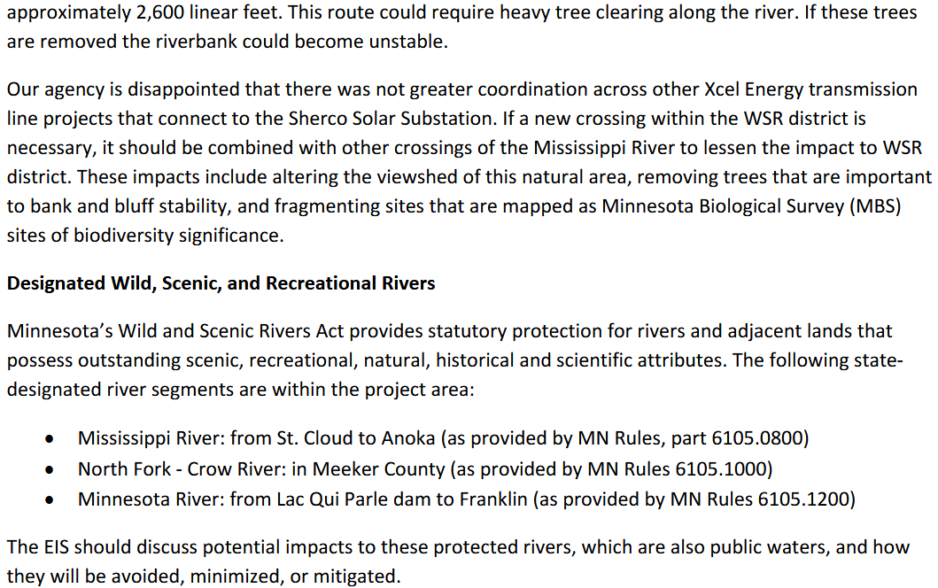
Hearing Exhibit EERA-4, DNR Comments, p. 184-185 of 227, February 21, 2024, 20243-204514-01
- The DNR also addressed crossings of Public Waters, over which it has jurisdiction, and requested discussion of transmission tower placement in relation to river and stream banks and floodplains, setbacks from stream banks… The EIS should include a robust discussion of methods to avoid, minimize, or mitigate potential impacts to these waters. Id.
- In this comment, the DNR twice raised in order the hierarchy of environmental protection, to avoid, minimize, or mitigate. Id.
- Following scoping, EERA released its Scoping Decision with additional Mississippi River crossing alternatives, in addition to other route segment alternatives. The Mississippi River crossings of 245 and 246 were added for consideration in the DEIS based upon Plaintiffs’ scoping comments and proposals:
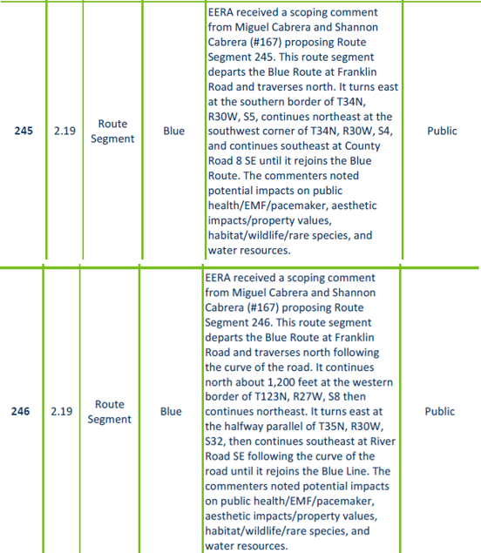

Hearing Exhibit EERA-9, Scoping Decision, Part 1, p. 34-35 of 47 20245-206732-02.
- These route segment alternatives are depicted in Appendix B, Maps, in the DEIS on map 2.19, in Part 2 20245-206732-04:
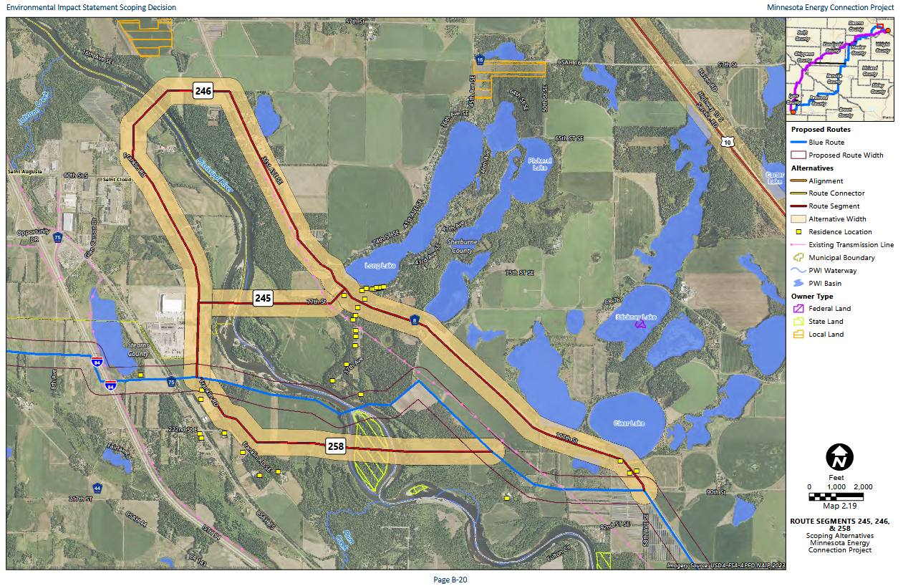
- This Scoping Decision map has two inexplicable choices in marking route alignments on a map . First, the existing transmission line, depicted in pink on the map, ends to the northeast at the 31st Ave. N.E. notation. Second, the route follows County Road 8, rather than the existing transmission line. Cabreras proposed specific alternatives for consideration with specific considerations. The drafters of the DEIS positioned Route Segment 246 on the northwestern side of County Road 8, directly over a large number of lake homes, rather than parallelling the existing transmission line on the opposite side of County Road 8 which also would impact fewer residences. That choice was made by the drafters of the EIS and not consistent with the Comments or routing criteria.
- The importance of these mapping choices is reflected in the mischaracterization of Cabreras’ comments. In the DEIS, EERA misrepresented the Comments of the Cabreras, claiming that “This route was proposed to avoid a decrease in property values to those who live along the river who expressed concern about aesthetic impacts.” DEIS, p. 431. This is false. As above, in Scoping Comments, the Cabreras, according to EERA’s chart, noted many specific potential impacts, on public health/EMF/pacemaker, aesthetic impacts/property values, habitat/wildlife/rare species, and water resources.
- This broad identification of issues is found in the Cabreras’ comments. Specific issues raised were area natural habitat, decline in biodiversity, habitat fragmentation, taking of eagles under migratory Bird Treaty Act, removal of vegetation and trees when routing along shoreline causing shoreline erosion, visual and noise impacts, impacts on tourism and recreation in area used for hunting, fishing, camping, rock hunting, tubing, and kayacking on the Water Trail, and the protections of the Mississippi River Scenic Act.
- The Cabreras proposed two route segment alternatives in comments of February 19 and 20th, alternatives which were incorporated into the DEIS review as route segments 345 and 246 and attributed to them. Id.
- The next map that was produced, the one used for DEIS evaluation, shows that there was a failure to put existing transmission crossing the river on the map, and that the existing transmission line, rather than continue north and across the river, simply ends in a field! Also, the choice of routing it on the lake side of County Road 8, with many homes, exacerbated impacts on residences, when placing it on the transmission line side, with existing infrastructure already routed through an area with far fewer homes would have had less of an impact.
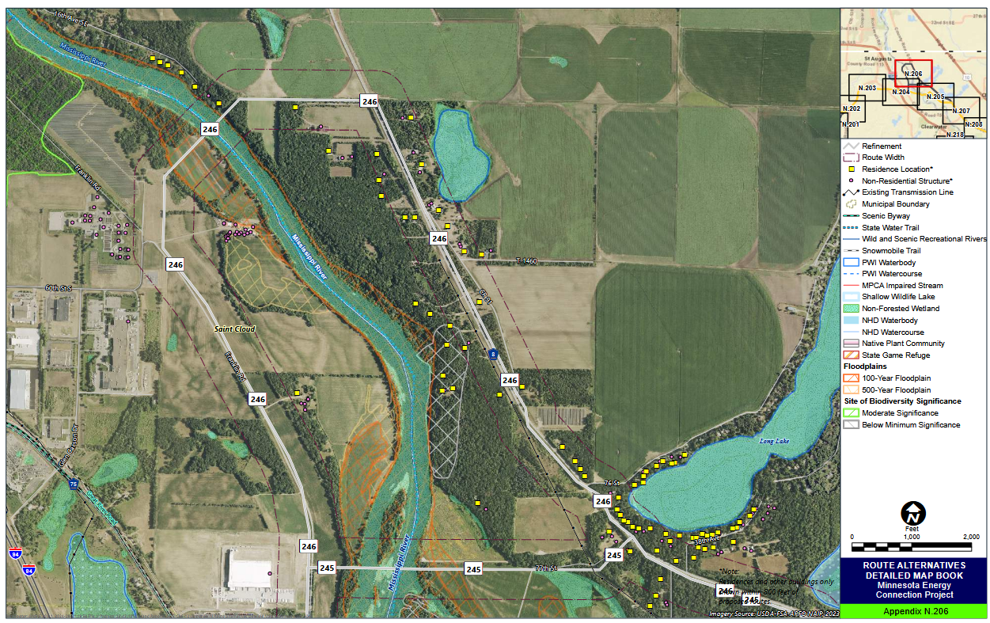
Hearing Exhibit EERA-12, DEIS Maps, Appendix N P-11, map N 206 202410-210806-13.
- Again, the northwest stretch of the existing transmission line is not depicted, including the existing transmission crossing of the Mississippi. This version of Segment 246 is not routed along the existing transmission line, but instead, along County Road 8, involving many more residences than it would had the existing transmission line corridor been utilized. This routing choice was made despite the consistent comments of the DNR to utilize existing transmission corridors, and the DEIS findings showing advantages of both Route Segments 245 and 246 when compared to the “equivalent” Blue Route:
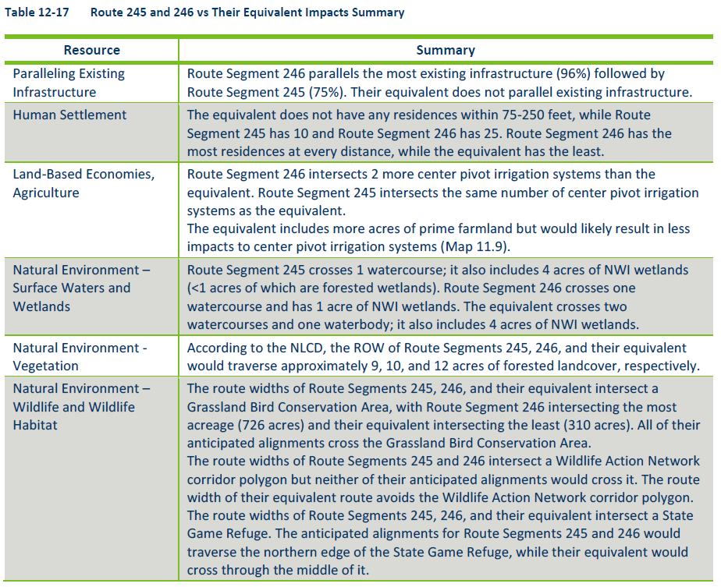
Hearing Exhibit EERA-12, DEIS, Full Text, p. 432, 202410-210801-01
- The DEIS states that Route Segment 245 is 4.2 miles long, and Segment 246 is 6.9 miles long, with the Blue Route is 3.5 miles long. That means that Route Segment 245 is 0.7 miles longer, and Segment 246 is 3.4 miles longer, where the route is approximately 180 miles long. The additional length is nominal, for 245, an increase of 0.4% and for 246, an increase of 1.9% over the 180 mile length of the route.
- During the PUC’s review of Xcel Energy’s transmission line application, Xcel filed a response to public comments in which it proffered a chart, together with narrative, presenting what it termed the “DNR Proxy Route.” Xcel’s “DNR Proxy Route” did not include any mention of the DNR’s “strongly preferred” Mississippi River Crossing utilizing either the Purple Route or Route Segment 246, both of which had existing crossings of the river.
- Though this “DNR Proxy Route,” included some of the DNR preferred route options, it excluded the “Region G” options that it “strongly preferred” for crossing the Mississippi River, specifically, the Purple Route and Route Segment 246.
- This “DNR Proxy Route” was discussed frequently in the Xcel and Administrative Law Judge’s Recommendation. The effect of Xcel’s “DNR Proxy Route” will be detailed below.
- On April 10, 2025, the Public Utilities Commission adopted the Recommendation of the Administrative Law Judge, with modifications, and issued a permit for routing of Xcel Energy’s Minnesota Energy Connection, roughly 180 miles from the Garvin substation in Lyon County to the Sherco substation in Sherco County:
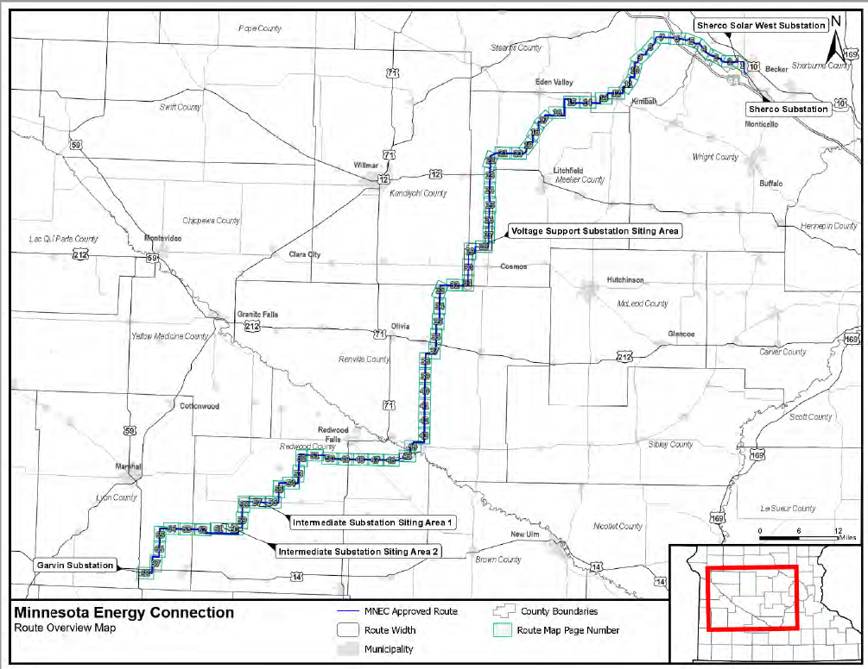
- The Mississippi River crossing at issue is on the Blue Route, as depicted in these two maps below and expanded to the 3.2 mile length:
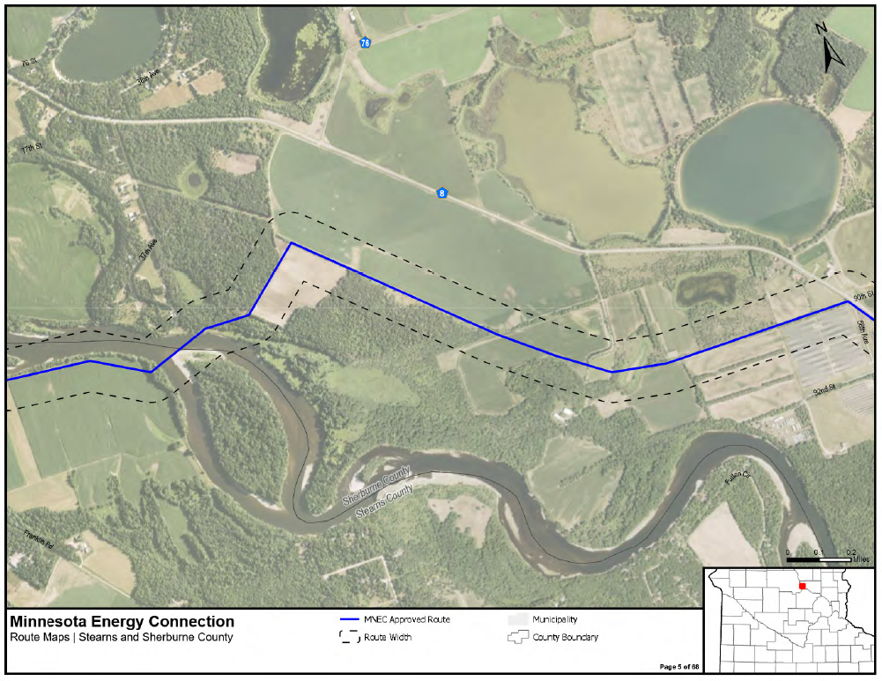
PUC Order, map 5 of 68, page 67 of the 140 page Order. June 11, 2025 20256-219826-01
DEIS, Appendix B, Maps, in the DEIS on map 2.19, in Part 2 20245-206732-04:

- Four alternatives were proposed by the Cabreras, roughly including Route Segments 245 and 246, specifically:
- Alternative 1: Prior to river crossing, along south border of field w Franklin Road, rather than north, then cross 100-200 yard to the South, past “Mississippi Island, on agricultural land where there are no houses.
- Alternative 2: Cross river 0.3 miles upstream at Island View County Park and hen connect to County Road 8.
- Alternative 3: Cross river 1.8 miles to the North where there is an existing power line crossing and less environmental impact.
- Alternative 4: A system alternative to bury the lines, providing security and protection from storms deep freezes, floods, and fires.

The Cabreras also commented on their preference of the Purple Route as a straight river crossing rather than the Blue Route’s crossing at an angle with heightened environmental impact.
- Another landowner on the Blue Line, Melody Vechal, noted the state Wild and Scenic River protections, and that it didn’t make sense that she is not allowed to cut a tree with a diameter of more than 4” but Xcel could put up a large transmission line. The river is used for kayaking and people should be able to enjoy the wilderness setting.
- Robert Klaverkamp, a landowner on the Stearns County side of the Blue Route crossing of the Mississippi River, also brought up environmental concerns, including a bald eagle nest on his property in the trees along the river. He also raised the restrictions along the shoreline, and believed that a 75 foot setback was required. As above, Sherburne and Stearns counties have protective Ordinances along the Mississippi River.
- The multiple Comments of the DNR repeatedly stated the agency’s “strong preference” for use of an existing Mississippi River crossing, giving two alternatives that would be better than the applicant’s preference. These alternatives preferred by the DNR are essentially those preferred by the Cabreras, the “Purple Route” crossing and Route Segment 246.
- A portion of the transmission route runs between a large wetland complex and commentors noted that the Mississippi River wetlands are federally protected.
- The many mature trees along Mississippi River banks provide an important ecosystem service that includes fish habitat, protection of fish habitat through shading, heat island mitigation, stormwater absorption, carbon sequestration, wildlife habitat, and improving air quality. The DNR also stated concerns about the impact of tree clearing and subsequent erosion to the riverbanks.
- Ron Schabel, a landowner near Monticello, commented at the Monticello Public Hearing, and referenced the DNR’s Minn. R. 6105.1800 and that along the Mississippi River, there are no entering areas within 200 feet of designated state Wild and Scenic and Recreational riverland, and land use districts, that the transmission line should avoid steep slopes on both sides.
- DNR COMMENTS WERE MISREPRESENTED BY XCEL AND “STRONG PREFERENCE” WAS BURIED

- The Public Utilities Commission has the responsibility of siting transmission lines, yet is a utility regulatory body, with regulatory expertise, not environmental expertise.
- Commerce-EERA is charged with environmental review for the Commission but does not have the necessary expertise in environmental matters, and relies on consultants to compile the Draft and Final Environmental Impact Statements.
- As above, the DNR is the agency charged with taking inventory of and protection of natural resources, the agency with the expertise regarding natural resources. DNR mission:
The mission of the Minnesota Department of Natural Resources (DNR) is to work with Minnesotans to conserve and manage the state's natural resources, to provide outdoor recreation opportunities, and to provide for commercial uses of natural resources in a way that creates a sustainable quality of life.

- PEER focus on environmental, preservation, over residences! AS ABOVE
- Courts typically defer to an agency based on the expertise of that agency, however, that long held precedent of Chevron has been turned on its head, and the dust is only now beginning to settle.
- The DNR met with Xcel Energy prior to its transmission line route application, and filed multiple comments for scoping and the DEIS.
- ALJ Recommendation – when referencing DNR comments, twice did refer to eDockets (NOT Hearing Record), and all other times, cited Xcel’s Response Comment using Xcel’s ________, and not the DNR Comment.
- Xcel Energy made up the “DNR Proxy Route” and filed this in its Response Comments…
- Does not include the DNR’s “strong preference” of Purple Route or Route Segment 246.87
- DNR Proxy Chart from Xcel Comments – used in Xcel’s Briefing (EERA’s?) ALJ Recommendation, Staff Briefing Papers, Commission Order and Permit, etc.
+++++++++++++
THE PUC AND XCEL ENERGY HAVE NO LEGITIMATE AFFIRMATIVE DEFENSE
- Where Cabreras have made a prima facie showing, the PUC and Xcel Energy may rebut that showing by providing contradictory evidence.
- Defendants PUC and Xcel may also rebut with:
… an “affirmative defense, that there is no feasible and prudent alternative and the conduct at issue is consistent with and reasonably required for promotion of the public health, safety, and welfare in light of the state’s paramount concern for the protection of its air, water, land and other natural resources from pollution, impairment, or destruction.

Minn. Stat. § 116B.04(b).

- The Defendants’ MERA-required “affirmative defense” to the plaintiff’s “prima facie showing” requires its proof that both (1) there is “no feasible and prudent alternative” to “the conduct at issue” and (2) “the conduct at issue” is “consistent with and required for promotion of the public health, safety, and welfare in light of the state’s paramount concern for the protection of its air, water, land and other natural resources from pollution, impairment, or destruction.” Minn. Stat. § 116B.04(b).
- As above, there are at least two feasible and prudent alternatives, alternatives that were both “strongly preferred” by the DNR, the Purple Route crossing and Route Segment 246. Get rid of this line!!

Alternatives may be excluded, but only if they meet any of the following criteria:

- Underlying need for or purpose of the project is not met.
- Significant environmental benefit over the proposed project is not provided.
- Another alternative is likely to be similar in environmental benefits but will have lesser socioeconomic impacts.

- The feasible and prudent alternatives of the Purple Route and Route Segment 246 do not meet any of the exclusionary criteria.

- In making a defense to the Cabrera’s challenges, an important statutory consideration is that “”(e]conomic considerations alone shall not constitute a defense hereunder.” Minn. Stat. § 116B.04(b).
- The Minnesota Energy Connection is overtly an economic based project, and the “need” for the project is stated clearly: Xcel’s desire to “preserve its valuable interconnection rights.” There is no electrical reliability basis for this project. In fact, this project, as an approximately 180 mile radial line, increases instability of the regional grid, so much so that series compensation must be added midway to provide voltage support at a cost of $85.4 million.
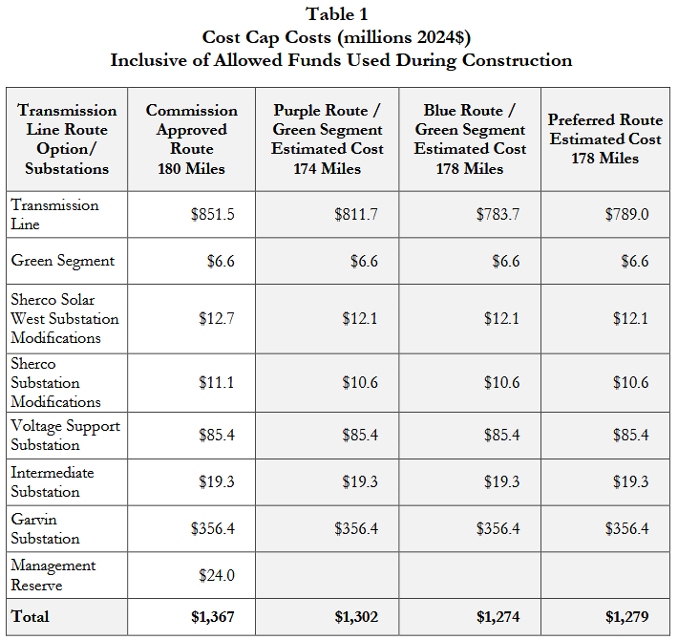
Xcel Energy, Compliance – Updated Project Cost Estimates, p. 2, September 5, 2025.

- This Court has jurisdiction over this matter pursuant to Minn. Stat. Ch. 116B, including Minn. Stat. §§ 116B.03, subd. 1, and 116B.10, and Minn. Stat. § 555.01, and this Court’s general jurisdiction inasmuch as the events that give rise to this action took place in Ramsey County, Minnesota, home of the Minnesota Public Utilities Commission.
THERE ARE AT LEAST TWO FEASIBLE AND PROUECT PROJECT ALTERNATIVES

- A required by MERA, there are alternatives to the Blue Route Mississippi River crossing preferred by Xcel Energy and chosen by the PUC.
- At least four alternatives to the Project have been considered in the EIS, and two of the route segments, the Purple Mississippi crossing and the Route Segment 246 crossing were “strongly preferred” by the DNR.
- Each of these alternatives would create substantially less negative impacts on natural resources than the Blue Line crossing. For example, the many mature trees along Mississippi River, and directly on the route selected by Xcel and the PUC provide an important ecosystem service that includes heat island mitigation, stormwater absorption, carbon sequestration, wildlife habitat, and improving air quality. Removal of trees…
THE DNR NOTED LIKELY LAND AND SOIL IMPACTS IN COUNTY SHORELAND AND BLUFFLAND PROTECTION ZONE.

- The Project will cause and contribute to significant negative impacts to the land and shoreline soils adjacent to the Mississippi River with the threat of additional erosion and destruction of land and soils caused by the removal of protective trees and vegetation and increase of impervious surface in close proximity to. High water and ice heaving threatens the land, soil, and alters the pathway of the river.
- Climate change increases extreme weather events such as heat waves so that large storms will become more frequent and more intense. A higher percentage of precipitation in Minnesota will come in the form of intense single-day events. (citation)
- The proposed Project will have long term adverse effects on the land and soils along the shore impact and shoreland zone of the Mississippi River.
- Areas of the transmission corridor travel through locations identified as floodplains.

- The Federal Emergency Management Association (FEMA) defines a floodplain as any area of land susceptible to being inundated by floodwaters from any source. This is typically the areas outside the channel or banks of a waterbody, but could be any kind of low-lying area of land. A floodplain’s natural functions impact storm runoff, water quality, vegetative diversity, wildlife habitat, and aesthetic qualities of our rivers and lakes. The Mississippi River floodplain is noted on the Stearns County GIS.

CAUSES OF ACTION

COUNT ONE: DECLARATORY JUDGMENT UNDER MERA

- Plaintiffs Cabreras incorporate all preceding paragraphs as if fully set forth herein.
- The Plaintiffs satisfy their “prima face showing” under MERA that the Project “is likely to cause the pollution, impairment, or destruction of the air, water, land or other natural resources located within the state.” Minn. Stat. §116B.03.
- The Cabreras have satisfied their “prima facie showing” under Minn. Stat. Ch. 116B (Minnesota Environmental Rights Act (MERA”) that the Project “is likely to cause the pollution, impairment, or destruction of the air, water, land, or other natural resources located within the state” given the State’s “paramount concern” for the environment. Minn. Stat. § 116B.04; State of Minnesota by Smart Growth Minneapolis v. City of Minneapolis, 954 N.W.2d 584, 596 (Minn. 2021).
- The 3.2 mile section of the 180 mile Minnesota Energy Connection transmission line is likely to cause impairment and destruction of the protected Mississippi River.
- The DNR’s Comments state unequivocally, repeatedly, that its “strong preference” is use of an existing transmission line crossing, either the Purple Route or Route Segment 246.
- In its first written comment, the DNR states:
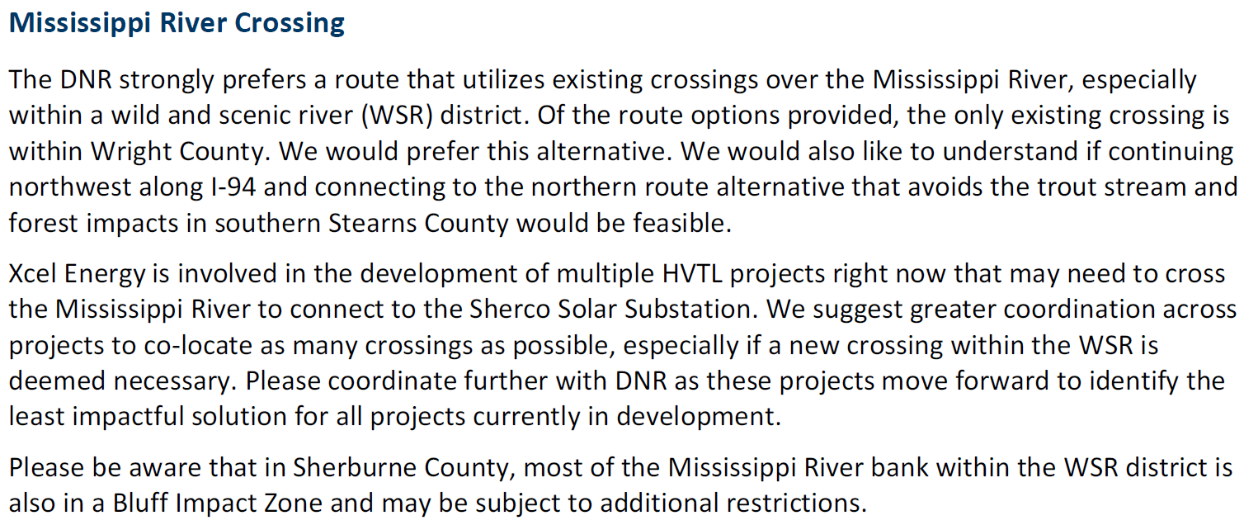
Hearing Exhibit Xcel-5, Appendix E of Route Permit Application (Revised), DNR Comment 7/10/2023, p. 28 of 110 (full Comment p. 27-33).
- The initial written DNR Comment requested greater coordination with and from Xcel:
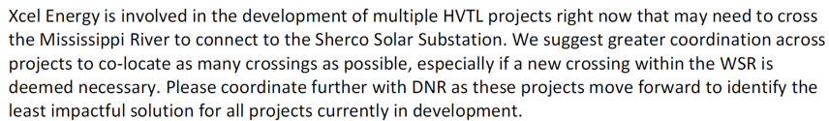
Hearing Exhibit Xcel-5, Appendix E of Route Permit Application (Revised), DNR Comment 7/10/2023, p. 28 of 110 (full Comment p. 27-33).
- That coordination did not occur:
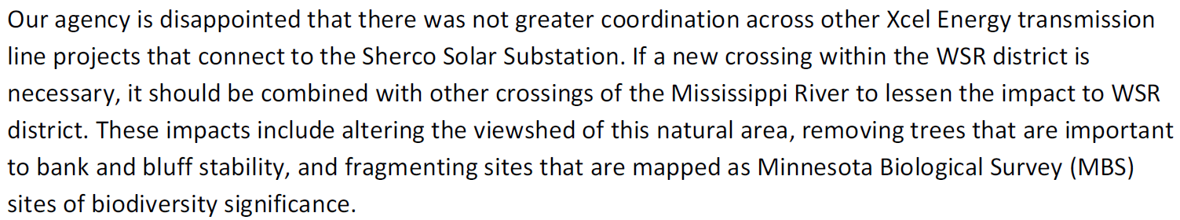
Hearing Exhibit EERA-4, Document 20243-204514-03, p. 184-185 (of 227 page pdf).
- Xcel Energy, the PUC, and Commerce-EERA did not give adequate consideration to the Comments of the DNR and the likely harm use of Xcel Energy’s preferred Blue Route crossing would cause to the Mississippi River, a protected natural resource.
- Xcel Energy, the PUC, and Commerce-EERA erroneously made avoidance of compensable residences, a higher priority than protection of the state’s non-compensable natural resources.
THERE ARE FEASIBLE AND PRUDENT ALTERNATIVES AVAILABLE
- As above, there are feasible and prudent alternatives available to the Blue Route crossing of the Mississippi that have been evaluated in the Environmental Impact Statement, specifically the Purple route or Route Segment 246.
- In its Comments, the DNR repeatedly stated it “strongly prefers a route that uses existing crossings over the Mississippi River, especially within a Wild and Scenic River (WSR) district. Minn. Stat. §103F.301. “Of the route options provided, the Purple Route in Wright County is the only route that uses an existing crossing. Our agency supports only the Purple Route crossing of the Mississippi River.” Hearing Exhibit EERA-4, Document 20243-204514-03, p. 184 (of 227 page pdf). This comment was made before the Draft Environmental Impact Statement was released which added Route Segments 244, 245 and 246. In later Comments, the DNR “strongly preferred” either the Purple Route, as above, or Route Segment 246, both of which utilized existing corridors to cross the Mississippi River.
- The project’s Mississippi River crossing is not compliant with the Public Utilities Commission’s own transmission routing rules requiring that:
No high voltage transmission line may be routed through state or national parks or state scientific and natural areas unless the transmission line would not materially damage or impair the purpose for which the area was designated and no feasible and prudent alternative exists. Economic considerations alone do not justify use of these areas for a high voltage transmission line.

Minn. R. 7850.4300, see also Minn. R. 6120.3300, Subp. 5 (2015); Minn. R. 6120.5900 (2008).
- A transmission crossing of a state protected Wild and Scenic and Recreational river with shoreland protective land-use ordinances on both sides of the river is not the purpose for which the area was designated, and this crossing would materially damage or impair its purpose.
- The Project’s 3.2 mile segment length of the 180 mile Blue Line route that includes the Mississippi River crossing is crossing a protectable natural resources pursuant to Minn. Stat. § 116B.02.
- The transmission project’s crossing of the Mississippi is likely to materially adversely affect the environment by the pollution, impairment, or destruction of protectable natural resources located at and surrounding the project area within the meaning of MERA. Minn. Stat. § 116B.03.
- The construction of the Minnesota Energy Connection’s Mississippi River crossing using the Blue Line route as proposed will pollute, impair, or destroy natural resources by materially despoiling the water quality, air quality, historic resources, and scenic and aesthetic resources, in and around Stearns and Sherburne County, State of Minnesota.
- The Public Utilities Commission has permitted, and Xcel Energy is constructing a Project that is likely to have a material adverse effect on protectable natural resources and the construction would violate MERA.
- As shown above, the Cabreras have met their MERA-required “prima face showing.”
- As shown above, the Cabreras are further entitled to both (1) an immediate injunction enjoining Xcel Energy’s implementation and construction of the Project and (2) an order remanding to the PUC for amending the routing permit and ordering utilization of one of the available alternative routes to the Blue Route for the Mississippi River Crossing.
- If modification to an alternative route is necessary and requires a supplemental EIS, that environmental review shall be performed.
COUNT TWO: INJUNCTIVE RELIEF UNDER MERA

- Plaintiffs incorporate all preceding paragraphs as if fully set forth herein.

- As Xcel Energy prepares to build this transmission line, securing land rights, taking soil samples, and other pre-construction activities, the Project poses a continuing and mounting threat to protectable natural resources including the Mississippi River and area surrounding the Blue Line crossing, in violation of MERA, and therefore cannot and should not be allowed in the manner and at the location planned, proposed, and approved.
- Based on the foregoing and all materials to be submitted to the Court, Plaintiffs are entitled to temporary and permanent declaratory and injunctive relief regarding the threats posed by the Project to protected natural resources.
- Because, as shown above, Plaintiffs have met their “prima facie showing,” a MERA claim has been stated and “relief” is compelled.
- Since the transmission line route was permitted, Xcel Energy is moving forward with routing, securing easements, testing soils, working on final engineering, finalizing purchasing and scheduling. Because of this activity, it is necessary to secure the status quo of this short 3.2 mile section of the project during the pendency of this proceeding.

PRAYER FOR RELIEF

Plaintiffs respectfully request the following relief:

  - A declaration in favor of Plaintiffs against the Public Utilities Commission and Xcel Energy that they have satisfied their MERA- required "prima facie showing" that the Project "is likely to cause the pollution, impairment, or destruction of the air, water, land or other natural resources located within the state."
  - A declaration in favor of Plaintiffs against the Public Utilities Commission and Xcel Energy that they have satisfied their MERA- required “prima facie showing” that the Project will violate environmental quality rules or standards and is thereby likely to cause the pollution, impairment, or destruction of the air, water, land or other natural resources located within the state
  - A temporary and permanent injunction immediately enjoining the Public Utilities Commission and Xcel Energy from constructing the Project during the pendency of this proceeding; and
  - A recovery by Plaintiffs against the County of their reasonable costs, disbursements, and attorney fees incurred in bringing and successfully prosecuting this MERA action.
  - Such other legal and equitable relief deemed appropriate by this Court.

LEGALECTRIC

Dated: October 27, 2025 ____________________________
Carol A. Overland
Attorney for Plaintiffs Shannon and Miguel Cabrera
Legalectric-Overland Law Office
1110 West Avenue
Red Wing, MN 55066

(612) 227-8638
overland@legalectric.org

ACKNOWLEDGEMENT

The undersigned hereby acknowledges that pursuant to Minn. Stat. § 549.21, Subd. 1, costs, disbursements and reasonable attorney and witness fees may be awarded to the opposing party or parties in this litigation if the Court should find that the undersigned acted in bad faith, asserted a claim or defense that is frivolous and that it is costly to the other party, asserted an unfounded position solely to delay the ordinary course of the proceedings or to harass; or committed a fraud upon the Court.

LEGALECTRIC

Dated: October 27, 2025 ____________________________
By: Carol A. Overland
Attorney for Plaintiffs Shannon and Miguel Cabrera
Legalectric-Overland Law Office
1110 West Avenue
Red Wing, MN 55066

(612) 227-8638
overland@legalectric.org

Xcel Energy’s Minnesota Energy Connection Routing Application, online at PUC eDockets 202310-199981-02
Xcel Energy’s Minnesota Energy Connection Revised Certificate of Need Application, p. 40 fn. 46 & 47, May 18, 2023, online at PUC eDockets 20235-195956-02
PUC - Order Modifying and Adopting Administrative Law Judge Report, Granting Certificate Of Need, and Issuing Route Permit for the Minnesota Energy Connection Project, June 11, 2025, online at PUC eDockets 20256-219826-01
Online at https://mn.gov/puc/about-us/what-we-regulate/background/
PUC Order Modifying and Adopting Administrative Law Judge Report, Granting Certificate of Need, and Issuing Route Permit for the Minnesota Energy Connection Project, June 11, 2025, online at eDockets 20256-219826-01
State Register Notice of Permit Decision, September 9 2025, online at eDockets 20259-222815-01; EQB Monitor Notice of Permit Decision, September 9, 2025, online at eDockets 20259-222815-02
PUC, Consent Order, May 2, 2023 available online at 20235-195506-01.
Online at https://mn.gov/commerce/about/
PUC Consent Order, p. 1-2, June 28 2022, online at 20226-186932-01.
Online at https://www.dnr.state.mn.us/aboutdnr/mission.html
Id.
Mississippi Scenic Riverway, Management Plan, online at https://files.dnr.state.mn.us/waters/watermgmt_section/wild_scenic/missplan_07-01-2004.pdf DNR site states that this is the most recent plan, following one in 1976. A request has been made for the maps referenced in this Plan.
Combined Hearing Exhibits, Xcel-5, Route Permit Application Appendix E (202310-199993-01), DNR Comment, p. 28 of 110, July 10, 2023
Hearing Exhibit Xcel-2, Route Permit Application, p. 26.
Direct Testimony of Langan, online at PUC eDockets 20249-210020-02.
ALJ Recommendation, pps. 211, 380, 455, 458, 512, 601, 673.
Hearing Exhibit Xcel-19 at 4, Langan Surrebuttal.
Minn. Rules 6105.0060
https://www.dnr.state.mn.us/watertrails/mississippiriver/segments-maps.html#map8
https://www.dnr.state.mn.us/watertrails/interactive_map/index.html
See Stearns County Ordinance 439, Article 12 https://www.ci.stcloud.mn.us/DocumentCenter/View/4077/Article-12---Overlay-Districts-and-Designated-Areas-7-08-24; https://content.civicplus.com/api/assets/8b957cd1-a288-4d0f-89b7-41e899d17730
Minn. Stat. §103F.305 SCENIC RIVER PROTECTION POLICY. The legislature finds that certain of Minnesota's rivers and their adjacent lands possess outstanding scenic, recreational, natural, historical, scientific and similar values. It is in the interest of present and future generations to retain these values, and a policy of the state, and an authorized public purpose to preserve and protect these rivers.
Minn. R. 7850.4400.
Id., see also https://files.dnr.state.mn.us/maps/canoe_routes/mississippi8.pdf
Spra fn 15.
See Stearns County GIS, 300’ overlay: https://datafi.wsbeng.com/#!prod/county!mn!stearns!public
See Sherburne County GIS Shoreland Overlay District: https://data-sherburnegis.opendata.arcgis.com/datasets/shoreland-district/explore?location=45.435542%2C-93.999355%2C10.94
Xcel Energy’s Minnesota Energy Connection Revised Certificate of Need Application, May 18, 2023, online at PUC eDockets 20235-195956-02
See also CoN Application pps. 1, 3, 4, 5, 13, 14, 15, 20, 21, 40, 43, 44, 57, 74, 75.
See In the matter of the 2020-2034 Upper Midwest Integrated Resource Plan of Northern States Power Company d/b/a Xcel Energy, Docket No. E-002/RP-19-368, Order, p. 25, April 15, 2022 (Fourth, the Commission concurs that, before Xcel starts a new process for building the Sherco gen-tie line, Xcel should describe its efforts to work with local governments and stakeholders to address any anticipated land use and planning challenges. Specifically, the Commission will order Xcel to consult with stakeholders to discuss these plans.) online at eDockets 20224-184828-01
Hearing Exhibit Xcel-2, Route Application, pps. 1, 58, online at PUC eDockets 202310-199981-02; see also Hearing Exhibit Xcel-20, Surrebuttal Testimony of Joseph Samuel, p.3, online at eDockets 202410-211225-03; ALJ Recommendation, FoF 431, project would enable interconnection of more than 4,000 M, February 5, 2025, online at PUC eDockets 20252-214994-01.
Hearing Exhibit Xcel 17, Direct Testimony of Joseph Samuel, p. 4-5, online at eDockets 20249-210020-03
Xcel Energy Compliance – Updated Project Cost Estimates, September 5, 2025, p. 1, online at eDockets 20259-222726-01
Xcel Energy Compliance – Updated Project Cost Estimates, September 5, 2025, online at eDockets 20259-222726-01
Evidentiary Hearing Combined Hearing Exhibit List, EERA-4, Public Scoping Comments, eDockets 20243-204514-03
Evidentiary Hearing Combined Hearing Exhibit List, eDockets 202410-211371-01, filed by Xcel 10/28/2024.
ALJ Recommendation, February 5, 2025, online at PUC eDockets 20252-214994-01
See Xcel Combined Exhibit List, 202410-211371-01, p. 5 of 8, Xcel-2, Application Narrative, p. 37, 202310-199981-02
Hearing Exhibit EERA-9, Scoping Decision Part 1 20245-206732-02; Part 2 20245-206732-04.
Hearing Exhibit EERA-9, Scoping Decision, Part 1, p. 34-35 of 47 20245-206732-02.
See Written comments of Miguel Cabrera November 25, 2024 202411-212348-01, Written Comments of Shannon Cabrera, November 25, 2024 202411-212349-01. Shannon and Miguel Cabreras’ Scoping Comment, February 20, 2024 20242-203668-02; Cabreras Scoping Comment, February 21, 2024 20242-203670-02 ; Miguel Cabrera Comment, Kimball Public Meeting, Comment, Transcript, pps. 27-30, January 31, 2024. See also Miguel Cabrera, Public Hearing Comment, Redwood Falls, transcript pps. 55-57; and November 7, 2024.
Xcel Energy Response to Hearing Comments, December 13, 2025, online at PUC eDockets 202412-212990-02.
Id.
ALJ Recommendation, February 5, 2025, Findings of Fact (x2), 385, 378, 378, 457, 458 and Table 458, 459, 604, 609, 638, 645, 646 Table 11, 670 Table 17-2 of DEIS and FEIS, 671, online at PUC eDockets 20252-214994-01
PUC - Order Modifying and Adopting Administrative Law Judge Report, Granting Certificate Of Need, and Issuing Route Permit for the Minnesota Energy Connection Project, June 11, 2025, online at PUC eDockets 20256-219826-01
Written comments of the Cabreras: Miguel Cabrera November 25, 2024 202411-212348-01; Shannon Cabrera, November 25,.2024 202411-212349-01; Cabreras Scoping Comment, February 20, 2024 20242-203668-02; Cabreras Scoping Comment, February 21, 2024 20242-203670-02; Miguel Cabrera Comment, Kimball Public Meeting, Comment, Transcript, p. 27-30, January 31, 2024, Miguel Cabrera, Public Hearing Comment, Redwood Falls, transcript p. 55-57, November 7, 2024.
Melody Vachal, Kimball public hearing, Transcript, p. 74-75, October 30, 2024.
Robert Klaverkamp, Kimball Public Hearing, Transcript pps. 73-75, 10/30/24
- https://www.epa.gov/cwa-404/protection-wetlands-executive-order-11990
Ron Schabel, Monticello Public Hearing, Transcript pps. 26-27, October 29, 2024.
Minn. Stat. §216E.02, Subd. 2.
Its mission is “to improve the lives of all Minnesotans by ensuring safe, reliable, and sustainable utility services at just and reasonable rates.”
See Transcript, Prehearing Conference 2, p. 7 (timing of Draft EIS release depends on “availability of consultants.”).
Online at https://www.dnr.state.mn.us/aboutdnr/mission.html
Loper-Bright online at https://www.supremecourt.gov/opinions/23pdf/22-451_7m58.pdf
Hearing Exhibit EERA-4 183-220 of 227 pages – note the DNR Comments are separated out from the jumble of public comments within that 227 page exhibit.
See Supra para. ___ - ___
Series Compensation is to be installed at a “Voltage Support” substation. From the application: c. Voltage Support (Series Compensation) Substation Xcel Energy proposes to construct a new 345 kV voltage support substation. This substation is currently proposed to include a Series Capacitor and one 150 MVAR STATCOM system per line. Selection of voltage support equipment will be dependent on the technologies available at the time of construction and the resources selected to interconnect to the line. A control building and road access will also be constructed at the site. Xcel Energy Route Application, p. 27, online at eDockets 202310-199981-02; Hearing Exhibit Xcel-18, Direct Testimony of Jason Standing, p. 4-5, online at eDockets 20249-210020-04.
Stearns County GIS, select “floodplain” layer: https://datafi.wsbeng.com/#!prod/county!mn!stearns!public
Id.

